**ABSTRACT:**

Every parent wants to find the right school for their child.

Well known saying in Sanskrit ‘VidyaAmritamManushyate’ which means education is just like elixir ( amrit ) for a person. The individual becomes a boon to the society only if he or she is educated.

There are so many school out there and but making a meaningful, fact based decision to choose one for your own child can be difficult. A school open day may present a prettified picture of the school, and it may be hard to make a judgement, as you led from corridor to the classroom, from one freshly cleaned hall to another sanitized study area. League table results can also be misleading as they may only take into consideration a single exam taken by year group. One cannot make a fair, and factual evaluation of a school.

School Quest offers up a wealth of information, including such fee structure, location, school board, co-ed or not and details of the infrastructure facilities. Basically all the details that one needs to make a fair decision for their child.

This web application will provide a platform for the user to choose the best educational institute for their child. Having a clear and authenticated pool of information provides an opportunity to compare different schools as well.

**TABLE OF CONTENTS**

Chapter 1**: Introduction……………………………………………PAGE NO.**

1.1) System Objective

1.2) Business Objective

1.3) Software Methodology

Chapter 2**: Literature Survey……………………………………..PAGE NO**

2.1) Existing System

2.2)Proposed System

Chapter 3: **Feasibility Study………………………………………PAGE NO.**

3.1) Introduction

3.2) Technical Feasibility

3.3) Economic Feasibility

3.4) Operational Feasibility

3.5) Legal Feasibility

3.6) Platform specification (Both Development and Deployment)

3.6.1) Hardware

3.6.2) Software implementation language/technology

Chapter 4:   **Requirement Specifications…………………………PAGE NO.**

4.1)Introduction

  4.2) Identification of Need

4.3) Preliminary Investigation

4.4) Requirements Elicitation

  4.5) System Specification

4.6) Specification of Function (Data flow Diagram)

4.7) Specification of Data (E-R Diagram)

Chapter 5**: Analysis of the System………………………………..PAGE NO.**

5.1) Introduction

5.2) Analysis of the system structure

Chapter 6: **Design of the System…………………………………PAGE NO.**

6.1) Introduction

6.2) System Design

6.3) Detailed Design

Chapter 7**: Software Implementation…………………………...PAGE NO.**

7.1) Modules of online Exam practice test

7.2) Role in the Project

Chapter 8**: Software Testing…………………………………PAGE NO.**

8.1) Objective of Testing

8.2) Types of Testing

8.3) Testing Process

Chapter 9 : **Screen Shots……………………………………..PAGE NO.**

Front End Designing

Chapter 10 **: Database tables (ScreenShots)………………...PAGE NO.**

Chapter 11**: Coding…………………………………………..PAGE NO.**

11.1 HTML code

11.2 CSS Code

11.3 PHP Code

Chapter 12 **: Limitation and Future Enhancements………...PAGE NO.**

Chapter 13: **Conclusion** **………………………………………PAGE NO.**

13.1) Summary

13.2) Limitations

13.3) Future Scope

***Chapter*** ***1***

Introduction & Purpose

**Chapter 1**

**Introduction**

**School Quest** is a solution where you can find the best school for your kid from the comfort of your home. Instead of going few miles away, you can compare school by sitting at your home and choose the best for your child. The platform SchoolQuest will provide all necessary information about the schools that are in your area. It provides information like fee structure, infrastructure, academics of school and much more. Users may also provide their feedback in the feedback section of the application. They can also contact the officials of the website in case of a query through the contact details provided to them on the website itself.

**Emotional Quotient-** Parents have a considerable interest in identifying links between personality traits and academic success. It has long been known that intelligence quotient alone is not the sole, or a particularly good, predictor of success. Factors other than traditional IQ scores can have a positive influence on students’ ability to succeed in academics, non-academics and life in general.

The four areas are:

• Self-awareness,

• Self-management,

• Social-awareness, and

• Relationship management.

* 1. **) System Objective**

School Quest is an application that includes two modules **–**

* **“Search for School”**is your own personal guide, designed to ease the lives of the parents in the city. It generates custom, desired outputs for you, based on your preferences and desires. In other words, it helps you plan your child’s education in best possible way.
* **“Know yourself”** is a emotional intelligence assessment test to determine EI of an individual. It is been found that 90% of the success is attributable to EI.

**Scope:**

There does not exist any such system for the city Indore. To solve the problem of better education of the children present in the city and even the new comers to the city, this system was proposed. Instead of going few miles away, one can compare school by sitting at their home and choose the best for their child.

There are many measurement tools available for EI with varying levels of complexity, expertize and cost required for proper administration. Henceforth our proposed system solves all the above specified problems. This framework will be developed to identify the students at most need of EI interventions.

* 1. **) Business Objective:**

**School Quest-** There is no existing system which guides parents according to their needs and requirements so as to efficiently choose a school for their ward.

**Emotional Intelligence-**We have seen that existing systems are not cost effective and moreover not implemented in our country. In countries like Dubai and Canada the system is implemented when the student enters the high school. The proposed system has a fuzzy based modelling approach. Proposed system captures uncertainties in surveys of new intakes, and which will deal well with the complexities of the classification system.

**1.2.1) Organisation of the Report.**

The report is organized into the following sections:

1. **Introduction**

This section talks about the objective, scope and motivation of this project. It introduces thereader to the topic of the Test Paper Generator, and how this project can help with thegeneration of the Test paper to the professors of any institute.

2. **Literature Survey**

This section talks about previous work that has been done in this field. We have listed a listof papers and publications which include work done in the same area as this project, that weused to draw inspiration from.

3. **System RequirementAnalysis**

This section covers the requirement analysis for the project. It includes sections aboutfeasibility study, information gathering and system requirements. It covers all the researchput into gaining insight about what it would take to create this project.

4. **System Analysis**

This section covers the model of the project. It is the report of the result of modeling performed on the project. It is the very first piece of tangible work performed for this project.It contains UML diagrams discussing and representing how the system will be structured andto whom it will cater.

5. **Design**

This section includes details about the design of the project. The architectural design of theApplication is a big highlight of this section. Apart from that, it contains the modularstructure of the project as well as different components that have been employed in it.

6. **Implementation**

This section contains some important excerpts of code from the deployed project. It explainshow some things are being done algorithmically in the project like hierarchal positioning ofquestions, difficulty assigning process and generating random papers.

7. **Testing**

This section contains details about different tests that were performed after the initialdevelopment of the project. It contains in depth figures about the unit tests performed on theproject, as well as some screenshots of the project in action.

**1.3) Software Methodology :**

Software development methodology implies dividing the workload into specific segments for its faster management. It also describes management methods used to increase the delivery efficiency, cooperation between development, design, testing, and other teams, as well as the product owner. Methodologies also regulate the participation of involved parties outside of the team, like clients and stakeholders. Project participants know how and when to control the project without interfering with the team.

Each methodology features a set of metrics and critical thresholds that showcase the team’s efficiency.

**1.3.1) Web Database Application :**

He overall objective in the development of database technology has been to treat data as an  organizational resource and as an integrated whole. DBMS allow data to be protected and  organized separately from other resources. Database is an integrated collection of data. The  most significant form of data as seen by the programmers is data as stored on the direct  access storage devices. This is the difference between logical and physical data.Database files  are the key source of information into the system. It is the process of designing database files,  which are the key source of information to the system. The files should be properly designed  and planned for collection, accumulation, editing and retrieving the required information.The organization of data in database aims to achieve three major objectives: The proposed system  stores the information relevant for processing in the MS SQL SERVER database. This  database contains tables, where each table corresponds to one particular type of information.  Each piece of information in table is called a field or column. A table also contains records, which is a set of fields. All records in a table have the same set of fields with different  Information.

There are primary key fields that uniquely identify a record in a table. There are also fields  that contain primary key from another table called foreign keys.

**1.3.2 ) Data Storage**

**MY SQL**

My SQL pronounced either "My S-Q-L" or "My Sequel," is an open source relational  database management system. It is based on the structure query language (SQL), which is  used for adding, removing, and modifying information in the database. Standard SQL  commands, such as ADD, DROP, INSERT, and UPDATE can be used with My SQL. My SQL can be used for a variety of applications, but is most commonly found on Web servers.  A website that uses My SQL may include Web pages that access information from a  database. These pages are often referred to as "dynamic," meaning the content of each page is  generated from a database as the page loads. Websites that use dynamic Web pages are often  referred to as database-driven websites. Many database-driven websites that use  My SQL also use a Web scripting language like PHP to access information from the  database. My SQL commands can be incorporated into the PHP code, allowing part or all of a  Web page to be generated from database information. Because both My SQL and PHP are  both open source (meaning they are free to download and use), the PHP/My SQL  combination has become a popular choice for database-driven websites. A relational database  stores data in separate tables rather than putting all the data in one big storeroom. The  database structures are organized into physical files optimized for speed. The logical model,  with objects such as databases, tables, views, rows, and columns, offers a flexible  programming environment. You set up rules governing the relationships between different  data fields, such as one-to-one, one-to-many, unique, required or optional, and “pointers” between different tables. The database enforces these rules, so that with a well-designed  database, your application never sees inconsistent, duplicate, orphan, out-of-date, or missing  data. The SQL part of “My SQL” stands for “Structured Query Language”. SQL is the most  common standardized language used to access databases. Depending on your

programming  environment, you might enter SQL directly (for example, to generate reports), embed SQL  statements into code written in another language, or use a language-specific API that hides  the SQL syntax.

### 

### software development process

The [software development process](https://www.softwaredevelopmentcompany.co/blog/software-requirements-specification/) unites several stages of product conception and execution. The most common are the following components of the process – idea generation, idea screening, concept development, marketing strategy development, business analysis, [product development](https://jelvix.com/blog/application-development-lifecycle), test marketing, commercialization.

## The most common software development methodologies

There are at least 20-30 software development methodologies out there. Some share key differences, like [Agile and Waterfall](https://jelvix.com/blog/agile-in-software-development), while others only vary in insignificant aspects. Here’s our ultimate review.

Developers are spoilt for choices from the various software development methodologies available. Most of the methodologies fall can be categorized as either a waterfall, iterative or continuous model.

A waterfall methodology follows a fixed sequence in implementation. Stages of development are defined in a rigid, sequential manner. This model was highly popular during the early days of programming due to the certainty in project scope. However, the rigidity of its structure also contributes to a high failure rate for many projects.

The iterative model offers an alternative for software development that’s less focused on rigid documentation but provides room for constant revisions. It uses multiple sprints to quickly build and test ideas to ensure they are relevant to users. As such, problems get fixed early on, and the team stays within the project’s goals. Agile and Scrum are two of the most popular iterative software development methodologies.

The continuous model is inspired by the Toyota Production System. It is about minimizing interruption or ensuring the flow between different phases of developments. The goal of the continuous software development approach is to avoid wastage and improve the efficiency of the various phases.

***Chapter2***

Literature

Survey

**Chapter 2**

**Literature Survey**

**2.1 Existing Systems**

There are many websites that offer close applications related to ours but there is no application that exists in India. There are applications designed and made in the other languages like German and Spanish. Some of these are:

**• School Hunt**

Compare over 25,000 school all in one place. Easily compare school's key information from all in one place. Clear visuals which compare national and local figures. We have OFSTED results and A-Level, GSCE and Key Stage 3 where available. Write parent school reviews or write your own to help other parents. Our service is completely free.

**• School hunters**

Schoolhunters.com is the perfect online source for people just like you who wish to pursue an academic career, find a better job, or earn an additional degree for their personal satisfaction. Our high quality selection of accredited universities with thousands of different educational programs can help you obtain the degree you are looking for. Go ahead and find out the universities available in your area by using the simple form on the left.

**2.2 Proposed System**

SchoolQuest will take tons of information such as location, board of education and annual fee structure, displaying it related to the individual’s preferences. Our web application which is been created on artificial bootstrap framework then gives the desired output over a responsive page. These information details about the schools could be selected from the database and viewed on any device either mobile phones or laptops or tablets. SchoolQuest will make easy way to gather the required information about the schools in the city. These big educational institutions may glorify their own existence but SchoolQuest would make you evaluate the numerous schools on similar ground and in an unbiased manner. Providing information even about the infrastructure and admission details, the website makes its existence even more powerful.

Parents have a considerable interest in identifying links between personality traits and academic success. It has long been known that intelligence quotient alone is not the sole, or a particularly good, predictor of success. Factors other than traditional IQ scores can have a positive influence on students’ ability to succeed in academics, non-academics and life in general.

The four areas are:

* Self-awareness,
* Self-management,
* Social-awareness, and
* Relationship management.

***Feasibility Study***

**Chapter 3**

**Feasibility Study**

**3) Information Gathering**

* The SchoolQuest model has data and sorted information about the schools in the city which was taken from MHRD website.
* Our EI based model is based on the published research paper of three scientists from Dubai Men’s College- FaouziBouslama, Michelle Housley and Andrew Steele.

**3.1) Feasibility Study Introduction:**

The objective of feasibility study is not only to solve the problem but also to acquire a sense of its scope. During the study, the Problem definition was crystallized and aspects of the problem to be included in the system are determined. Consequently, benefits are estimated with greater accuracy at this stage. A feasibility study is an analysis that considers all of a project's relevant factors—including economic, technical, legal, and scheduling considerations—to ascertain the likelihood of completing the project successfully.

Whether a project is feasible or not can depend on several factors, including the project's cost and [return on investment](https://www.investopedia.com/terms/r/returnoninvestment.asp), meaning whether the project generated enough [revenue](https://www.investopedia.com/terms/r/revenue.asp) or sales from consumers.

However, a feasibility study isn't only used for projects looking to measure and forecast financial gains. In other words, feasible can mean something different, depending on the industry and the project's goal. For example, a feasibility study could help determine whether a hospital can generate enough donations and investment dollars to expand and build a new cancer center.

Although feasibility studies can help project managers determine the risk and return of pursuing a plan of action, several steps and best practices should be considered before moving forward.

**Feasibility Analysis**

Analysis determines whether the system is Feasible within the socio technical framework of  the organization. Feasibility study can be done for following points –

➢ Technical Feasibility

➢ Legal Feasibility

➢ Operational Feasibility

➢ Economic Feasibility

**3.2)Technical Feasibility**

• Technical Feasibility consider whether available technology suffices for technical needs of proposed system this analysis is used to know availability of the various tools, programming languages and development environments. Tools and Technologies used: Java, MySQL Database, Bootstrap.

• It involves determining whether or not a system can actually be constructed to solve the problem at hand. Some users expect too much of computer, assuming that computers can accurately predicted future, immediately reflect all information in an organization, easily understand speech, or figure out how to handle difficult problems.

• The technical purchases raised during the feasibility stages of the investigation are:

1. Does the necessary technology exist (can it be acquired) to do what is suggested?

2. Does the proposed equipment have the technical capacity to hold the data required to use the new system?

3. Will the proposed system and components provide adequate responses to enquiries, regardless of the number or location of users?

4. Can be system expanded, if developed?

**We had found in our analysis that there are quite sufficient technical resources available at the organization and capable of handling user requirements.**

**3.3) Economical Feasibility**

• It involved estimating benefits and costs. These benefits and cost may be tangible or intangible. Tangible benefits may include deceasing salary costs (by automating manual procedures), preventing costly but frequent errors, sending bill earlier in the month, and increasing control over inventory levels. Such benefits may directly estimate in rupees without much trouble. Tangible cost is easily estimated. Intangible benefits may include increasing quality of goods produced, upgrading or creating new customers, and developing a better understanding of the market.

• The economic and financial questions raised by analysts during the preliminary investigation seek estimates of:

1. The cost to conduct a full System investigation.

2. The cost of hardware and software for the class of application being considered.

3. The benefits in the form of reduced costs or fewer costly errors.

4. The cost if nothing changes (the system is not developed). Because of already availability of computer software and hardware in the organization it is economical feasible.

**We had found in our analysis that as college students we are not financially able to implement and build this project on our own but if developed and implemented by a business organization it can be profitable**

**3.3) Operational Feasibility**

Operational feasibility is the measure of how well a proposed system solves the problems, and takes advantage of the opportunities identified during scope definition and how it

satisfies the requirements identified in the requirements analysis phase of system development.[[14]](https://en.wikipedia.org/wiki/Feasibility_study#cite_note-SAD-Global_Enterprise-14)

The operational feasibility assessment focuses on the degree to which the proposed development project fits in with the existing business environment and objectives with regard to development schedule, delivery date, [corporate culture](https://en.wikipedia.org/wiki/Corporate_culture) and existing business processes.

To ensure success, desired operational outcomes must be imparted during design and development. These include such design-dependent parameters as reliability, maintainability, supportability, usability, producibility, disposability, sustainability, affordability and others. These parameters are required to be considered at the early stages of design if desired operational behaviours are to be realised. A system design and development requires appropriate and timely application of engineering and management efforts to meet the previously mentioned parameters. A system may serve its intended purpose most effectively when its technical and operating characteristics are engineered into the design. Therefore, operational feasibility is a critical aspect of systems engineering that needs to be an integral part of the early design phases.

**3.4) Legal Feasibility**

It determines whether the proposed system conflicts with legal requirements, e.g., a data processing system must comply with the local data protection regulations and if the proposed venture is acceptable in accordance to the laws of the land.

**3.5)Behavioural Feasibility**

In behavioural feasibility study we have studied my department which is full supporting to me for working on project. Cooperative nature of our project guide and all the faculty members is appreciative. Hence, we decided our team is capable for making this system with proper and continues guidance.

**3.6)Platform specification (Both Development and Deployment)**

**3.6.1) Hardware**

The application is meant to be a web application, multiple-user system. The application will run on any system Android mobile device or a Desktop. No further hardware devices or interfaces will be required. User just needs the internet connectivity to access the web application – SchoolQuest.

**3.6.2 Software**

Software Specification The application will be developed through java using bootstrap framework. The application will include databases which will be implemented with the use of MySQL for the purpose of maintaining the details of the schools and users contact details. Most importantly for maintaining the record of the places to visit in a particular city.

**Chapter -4**

**Requirement Specification**

**4.1 Introduction**

This document is the basic intended for any individual user, developer, tester, project  manager or documentation writer that needs to understand the basic system architecture and  its specifications

The purpose of this SRS document is to write the functional and non functional user or  system requirements that represent the characteristics of On-Line Exam System.

The scope and limitation of this system is:

✓ The on-line exam system design to educational institutes.

✓ Hold all operation and generate reports to student, and administrator.

✓ Support multiple choices questions.

**4.2 Identification of Need**

Education of any kind is necessary for man to develop socially and intellectually. Everyday  we learn something new. An education should be rooted to culture and committed to  progress. Each of us has a social personality that is different from everyone else, we also have  a learning personality that is different from everyone else. Our learning personality is the  combination of natural talent, personal interest, current opportunity, social environment,  character, motivation and how the brain processes information. In today’s world this learning  capability is judged by means of examinations. Examinations are every important in judging  one’s personality. Thus, the need of exams today in universities, schools, colleges and even  companies for recruitment purposes. The general paper-pen tests/exams are now slowly being  replaced by the online internet based testing system.

**4.3Preliminary Investigation**

Something that proceeds, prepares for, or introduces the main matter, action, or business. An  academic test or examination that is preparatory to one that is longer, more complex, or more  important. Context to determine the finalists in a competition.

**4.4Requirements Elicitation**

**4.4.1 Functional or Specific Requirements**

Required software is for conducting on-line objective type examination and providing  immediate results. The system should satisfy the following requirements

**Administrator Aspect**

1. Taking backup of the database

2. Editing/Deleting/Creating the database.

3. Adding record of candidate.

4. Changing the super password.

**Student Aspect:**

To access at this stage of system development processes. It involve the study of functions,  performance and constraints that may affect the ability to achieve an acceptable system. The  identification of needs and feasibility study says that system is technically feasible. **Hardware Specification**:

➢ 600MHz processor

➢ Hard Disk: 10GB(Minimum)

➢ RAM:250(MB)

**Software Specification:**

**PHP (Hypertext Preprocessor**)

The PHP Hypertext Preprocessor (PHP -- yes, the first "P" in the acronym does indeed stand  for PHP!) allows web developers to create dynamic content that interacts with databases.  PHP applications are normally found on Linux servers and in conjunction with MySQL  databases. It provides those servers with functionality similar to that provided to the  Windows platform by Active Server Pages technology.

**SQL Server My SQL**

My SQL, pronounced either "My S-Q-L" or "My Sequel," is an open source relational  database management system. It is based on the structure query language (SQL), which is  used for adding, removing, and modifying information in the database. Standard SQL  commands, such as ADD, DROP, INSERT, and UPDATE can be used with My SQL .My SQL can be used for a variety of applications, but is most commonly found on Web servers.  A website that uses My SQL may include Web pages that access information from a  database. These pages are often referred to as "dynamic," meaning the content of each page is  generated from a database as the page loads. Websites that use dynamic Web pages are often  referred to as database-driven websites. Many database-driven websites that use My SQL  also use a Web scripting language like PHP to access information from the database. My SQL commands can be incorporated into the PHP code, allowing part or all of a Web page to  be generated from database information. Because both My SQL and PHP are both open  source (meaning they are free to download and use), the PHP/My SQL combination has  become a popular choice for database-driven websites.

**Any Web Browser**

The Firefox project began as an experimental branch of the Mozilla project by Dave Hyatt,  Joe Hewitt . They believed the commercial requirements of Netscape's sponsorship and  developer-driven feature creep compromised the utility of the Mozilla browser.[26] To combat  what they saw as the Mozilla Suite's software bloat, they created a stand-alone browser, with  which they intended to replace the Mozilla Suite. On April 3, 2003, the Mozilla Organization announced that they planned to change their focus from the Mozilla Suite to Firefox and  Thunderbird.[27]

**Pre-Implementation software requirements:**

**Xampp Server**

XAMPP is an open-source web server package that works on various platforms. Is actually  an acronym with X meaning “cross” platform, A for Apache HTTP server, M for MySQL, P  for PHP, and P for Perl. XAMPP was designed to help webpage developers, programmers,  and designers check and review their work using their computers even without connection to  the web or internet. So, basically XAMPP may be used to stand as pages for the internet even  without connection to it. It can also be used to create and configure with databases written in  My SQL since XAMPP is designed as a cross-platform server package, it is available for a  variety of operating systems and platforms like Microsoft Windows, Mac OS X, Linux, and  Solaris.

**4.4.2Non-Functional System Requirements**:

**Performance Requirement** Some Performance requirements identified is listed below: The  database shall be able to accommodate a minimum of 10,000 records of students. The  software shall support use of multiple users at a time. There are no other specific performance  requirements that will affect development.

**Safety Requirements** The database may get crashed at any certain time due to virus or  operating system failure. Therefore, it is required to take the database backup.

**Security Requirements**

Some of the factors that are identified to protect the software from accidental or malicious access, use,  modification, destruction, or disclosure are described below. Keep specific log or history data sets  Assign certain functions to different modules Restrict communications between some areas of the  program Check data integrity for critical variables Later version of the software will incorporate  encryption techniques in the user/license authentication process. Communication needs to be  restricted when the application is validating the user or license. (i.e.using https).

**4.5 System Specification**

**4.5.1 Software Quality Attributes:** The Quality of the System is maintained in such a way  so that it can be very user friendly to all the users.

The software quality attributes are assumed as under:

✓ Accurate and hence reliable.

✓ Secured.

✓ Fast speed.

✓ Compatibility.

**4.5.2 System Interfaces:**

This section describes how the software interfaces with other software products or users for  input or output.

**User Interface**

Application will be accessed through a Browser Interface. The interface would be viewed  best using 1024 x 768 and 800 x 600 pixels resolution setting. The software would be fully  compatible with Microsoft Internet Explorer for version 6 and above. No user would be able  to access any part of the application without logging on to the system.

***Hardware Interfaces***

**Server Side**:

Operating System: Windows 9X/XP, Windows ME

Processor: Pentium 3.0 GHz or higher

RAM: 256 Mb or more

Hard Drive: 10 GB or more

**Client side:**

Operating System: Windows 9x or above, MAC or UNIX.

Processor: Pentium III or 2.0 GHz or higher.

RAM: 256 Mb or more

***Software Interfaces***

*Client Side: .HTML, Web Browser, Windows XP/2000/Vista*

Web Server:.HTML, Windows XP/2000/Vista

**4.6 Specification of Function (Data flow diagram)**

**Data Flow Diagram**

Data Flow Diagrams (DFD) helps us in identifying existing business processes. It is a  technique we benefit from particularly before we go through business process re-engineering. At it’s simplest, a data flow diagram looks at how data flows through a system. It concerns  things like where the data will come from and go to as well as where it will be stored. But  you won't find information about the processing timing (e.g. whether the processes happen in  sequence or in parallel).DFDs only involve four symbols. They are Process, Data Object,

Data Store, External entity

** Process**

Transform of incoming data flow(s) to outgoing flow(s).

** Data Flow**

Movement of data in the system.

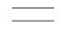 **Data Store**

Data repositories for data that are not moving. It may be as simple as a buffer  or a queue or a s sophisticated as a relational database.

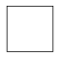 **External Entity**

Sources of destinations outside the specified system boundary.

**Level 0 (Context Level)Data Flow Diagram:**

**Context Diagrams (0 levels):**

A context diagram is a top level (also known as Level 0) data flow diagram. It only contains  one process node (process 0) that generalizes the function of the entire system in relationship  to external entities.

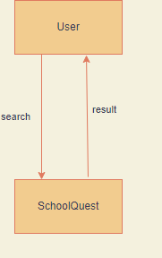

**Fig. 0 level DFD (Context Diagram)**

**Level 1 Data Flow Diagram:**

Data flow diagram is that which can be used to indicate the clear progress of a business  venture. In the process of coming up with a data flow diagram, the level one provides an  overview of the major functional areas of the undertaking. After presenting the values for  most important fields of discussion, it gives room for level two to be drawn.

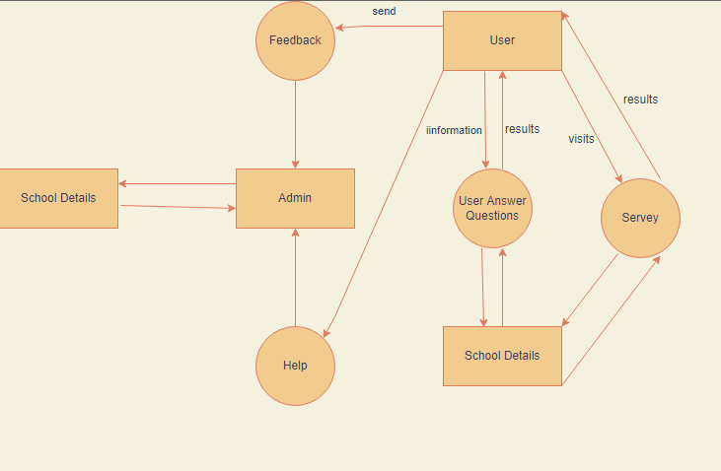

**4.7 Specification of Data (E-R Diagram)**

An entity-relationship diagram is a data modeling technique that creates a graphical  representation of the entities, and the relationships between entities, within an information  system. The three main components of an ERD are:

• The entity is a person, object, place or event for which data is collected. For example,  if you consider the information system for a business, entities would include not only  customers, but the customer's address, and orders as well. The entity is represented by  a rectangle and labelled with a singular noun.

• The relationships the interaction between the entities. In the example above, the  customer places an order, so the word "places" defines the relationship between that  instance of a customer and the order or orders that they place. A relationship may be  represented by a diamond shape, or more simply, by the line connecting the entities.  In either case, verbs are used to label the relationships.

• The co-ordinate defines the relationship between the entities in terms of numbers. An  entity may be optional: for example, a sales rep could have no customers or could  have one or many customers; or mandatory: for example, there must be at least one  product listed in an order. There are several different types of cardinality notation;  crow's foot notation, used here, is a common one. In crow's foot notation, a single bar  indicates one, a double bar indicates one and only one (for example, a single instance  of a product can only be stored in one warehouse*), a circle indicates* zero, and a  crow's foot indicates many. The three main cardinal relationships are: one-to-one,  expressed as 1:1; one-to-many, expressed as one to many; and many-to-many,  expressed as many to one.The steps involved in creating an ERD are:

• Identify the entities.

• Determine all significant interactions.

• Analyze the nature of the interactions.

• Draw the ERD.

An entity may be defined as a thing which is recognized as being capable of an independent  existence and which can be uniquely identified. An entity is an abstraction from the  complexities of a domain. When we speak of an entity, we normally speak of some aspect of  the real world which can be distinguished from other aspects of the real world.An entity may  be a physical object such as a house or a car, an event such as a house sale or a car service, or  a concept such as a customer transaction or order. Although the term entity is the one most  commonly used, following Chen we should really distinguish between an entity and an  entity-type. An entity-type is a category. An entity, strictly speaking, is an instance of a given  entity-type. There are usually many instances of an entity-type. Because the term entity-type  is somewhat cumbersome, most people tend to use the term entity as a synonym for this term.

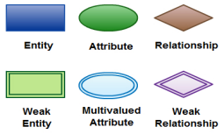

There are three basic elements in an ER Diagram: entity, attribute, relationship. There are  more elements which are based on the main elements. They are weak entity, Multivalues  attribute, derived attribute, weak relationship and recursive relationship. Cardinality and  ordinality are two other notations used in ER diagrams to further define relationships.

**Entity:-**An entity can be a person, place, event, or object that is relevant to a given system.  For example, a school system may include students, teachers, major courses, subjects, fees,  and other items. Entities are represented in ER diagrams by a rectangle and named using  singular nouns.

**Weak Entity:-**A weak entity is an entity that depends on the existence of another entity. In  more technical terms it can defined as an entity that cannot be identified by its own attributes.  It uses a foreign key combined with its attributed to form the primary key. An entity like order item is a good example for this. The order item will be meaningless without an order  so it depends on the existence of order.

**Attribute:-**An attribute is a property, trait, or characteristic of an entity, relationship, or  another attribute. For example, the attribute Inventory Item Name is an attribute of the entity  Inventory Item. An entity can have as many attributes as necessary. Meanwhile, attributes can  also have their own specific attributes. For example, the attribute “customer address” can  have the attributes number, street, city, and state. These are called compositeattributes. Note  that some top level ER diagrams do not show attributes for the sake of simplicity. In those  that do, however, attributes are represented by oval shapes.

**Derived Attribute**:-An attribute based on another attribute. This is found rarely in ER  diagrams. For example for a circle the area can be derived from the radius.

**Relationship**:-A relationship describes how entities interact. For example, the entity  “carpenter” may be related to the entity “table” by the relationship “builds” or “makes”.  Relationships are represented by diamond shapes and are labeled using verbs.

**Recursive Relationship:-**If the same entity participates more than once in a relationship it is  known as a recursive relationship. In the below example an employee can be a supervisor and  be supervised, so there is a recursive relationship

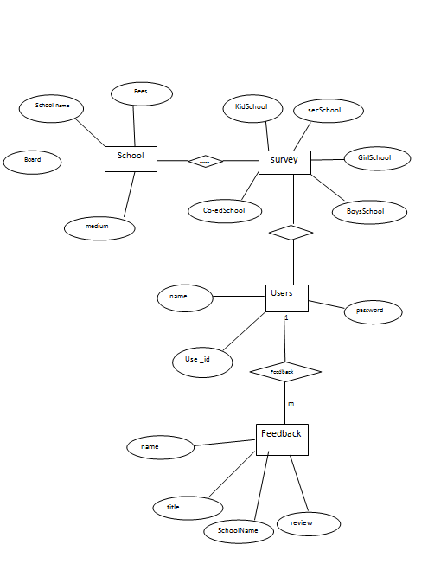

**Chapter 5**

**Analysis of the system**

**5.1 Introduction :**

Design is the abstraction of a solution; it is a general description of the solution to a problem

without the details. Design is view patterns seen in the analysis phase to be a pattern in a

design phase. After design phase we can reduce the time required to create the

implementation.

**5.2 Analysis of the System structure**

5.2.1 Functional model(Use-Case diagram) and specifications:A use case diagramat its

simplest is a representation of a user's interaction with the system and depicting the

specifications of a use case A use case diagram can portray the different types of users of a

system and the various ways that they interact with the system. This type of diagram is

typically used in conjunction with the textual use case and will often be accompanied by

other types of diagrams as well.

## Interface Notation

Interface is represented by a circle as shown in the following figure. It has a name which is generally written below the circle.

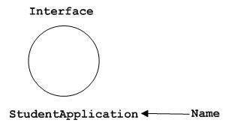

Interface is used to describe the functionality without implementation. Interface is just like a template where you define different functions, not the implementation. When a class implements the interface, it also implements the functionality as per requirement.

## Collaboration Notation

Collaboration is represented by a dotted eclipse as shown in the following figure. It has a name written inside the eclipse.

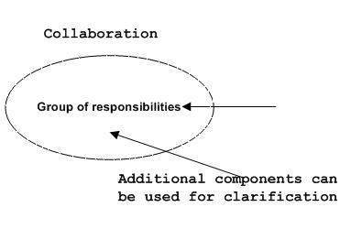

Collaboration represents responsibilities. Generally, responsibilities are in a group.

## Use Case Notation

Use case is represented as an eclipse with a name inside it. It may contain additional responsibilities.

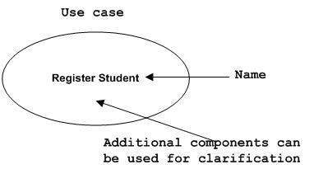

Use case is used to capture high level functionalities of a system.

## Actor Notation

An actor can be defined as some internal or external entity that interacts with the system.

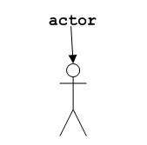

## Initial State Notation

Initial state is defined to show the start of a process. This notation is used in almost all diagrams.

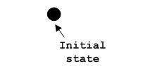

The usage of Initial State Notation is to show the starting point of a process.

## Final State Notation

Final state is used to show the end of a process. This notation is also used in almost all diagrams to describe the end.

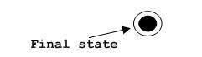

The usage of Final State Notation is to show the termination point of a process.

## Active Class Notation

Active class looks similar to a class with a solid border. Active class is generally used to describe the concurrent behavior of a system.

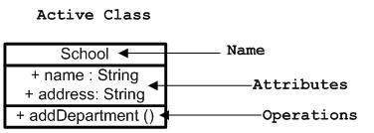

Active class is used to represent the concurrency in a system.

**5.2.1 Use Case Diagram** :- A use case diagram at its simplest is a representation of a user's interaction with the system that shows the relationship between the user and the different use cases in which the user is involved.

**USE CASE : User**

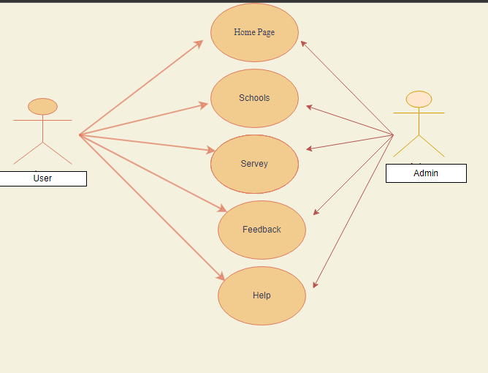

**USECASE : Admin**

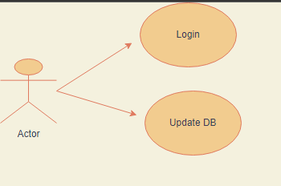

5.1.2 Use Case Description

5.1.2.1 Homepage

5.11.2.1.1 Brief Description

This use case is used to have the first look to our web application. By coming onto the homepage the user can access all the schools in the city and their information and contact details.

Flow of events

**Basic Flow:** The system will ask for user’s email-ID and mobile number to keep them informed about any changes in the schools of their choice. All the details should be filled by the user correctly. If the details are correct user will be directed to a page with the schools and institutes of his or her preference.

**Alternative Flow:** If in case the user directly wants the list of schools present in the city, they can move to the survey column directly. There exists the entire list of schools present the city categorized as primary, secondary and all schools.

Flow of events

**Basic Flow:** It is simply the webpage displaying the registered schools with MHRD in the city. All the information about the school is just a click away from the user. For extraneous desire of more information a direct link is also available for the user.

###### **Alternative Flow**: None

Flow of events

**Basic Flow:** Writing up a feedback and sending either with the contact details or anonymously.  **Alternative Flow:** None.

**5.2.2 Analysis object model (Class Diagram)**

**Class diagram**: A class diagram is an illustration of the relationships and source code dependencies among classes in the Unified Modeling Language (UML). In this context, a class defines the methods and variables in an object, which is a specific entity in a program or the unit of code representing that entity.

**CLASS DIAGRAM**:-User

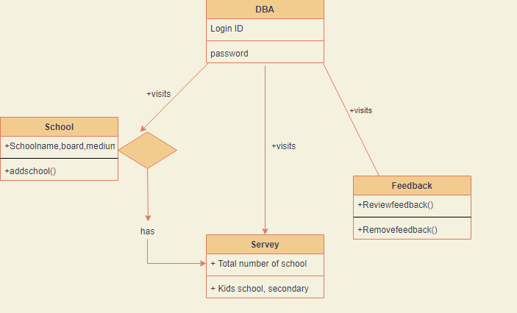

**Fig. Class Diagram -User**

**CLASS DIAGRAM:- Admin**

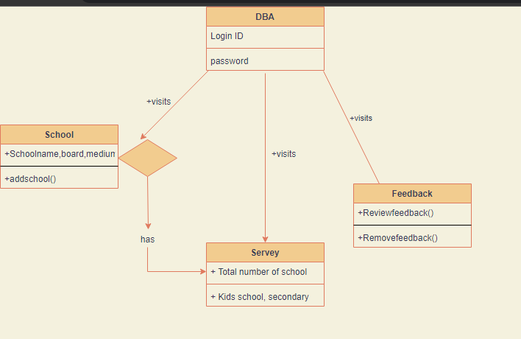

**Fig. Class Diagram -Admin**

**5.2.3Dynamic model (Sequence Diagram)**

A sequence diagram is a kind of interaction diagram that shows how processes operate with

one another and in what order. It is a construct of a Message Sequence Chart .A sequence

diagram shows object interactions arranged in time sequence. It depicts the objects and

classes involved in the scenario and the sequence of messages exchanged between the objects

needed to carry out the functionality of the scenario. Sequence diagrams are typically

associated with use case realizations in the Logical View of the system under development.

Sequence diagrams are sometimes called event diagrams, event scenarios.

**Sequence Diagram**

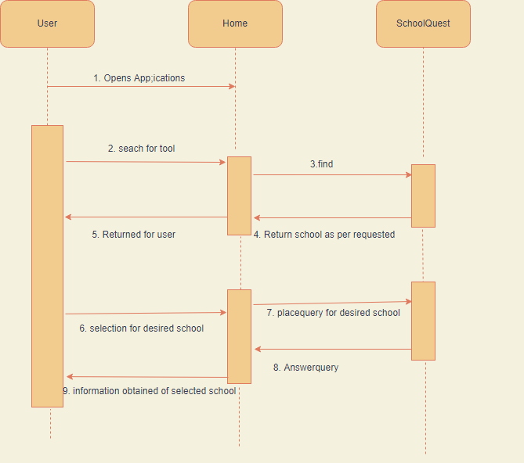

**5.2.4 Dynamic model (Activity Diagram)**

**Activity diagram**:

Activity diagram is another important diagram in UML to describe the dynamic aspects of the system. Activity diagram is basically a flowchart to represent the flow from one activity to another activity.

Activity diagrams are constructed from a limited number of shapes, connected with arrows. The most

important shape types:

• rounded rectangles represent actions;

• diamonds represent decisions;

• bars represent the start (split) or end (join) of concurrent activities;

• a black circle represents the start (initial state) of the workflow

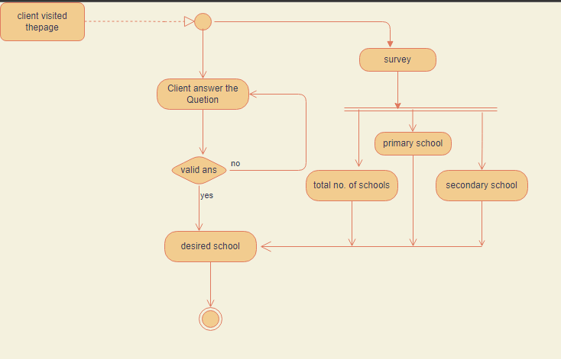

**Fig. Activity Diagram**

**Chapter 6**

**Design of the System**

**6.1 Introduction**

**6.3.1 Deployment Diagram**

A deployment diagram in the Unified Modeling Language models the *physical* deployment of  art- fraction nodes. To describe a web site, for example, a deployment diagram would show  what hardware components ("nodes") exist (e.g., a web server, an application server, and a  database server), what software components ("artifacts") run on each node (e.g., web  application, database), and how the different pieces are connected .The nodes appear as  boxes, and the artifacts allocated to each node appear as rectangles within the boxes. Nodes  may have sub nodes, which appear as nested boxes. A single node in a deployment diagram  may conceptually represent multiple physical nodes, such as a cluster of database servers.  Device nodes are physically computing resources with processing memory and services to  execute software, such as typical computer or mobile phones. An execution environment  node (EEN) is a software computing resource that runs within an outer node and which itself  provides a service to host and execute other executable software elements.

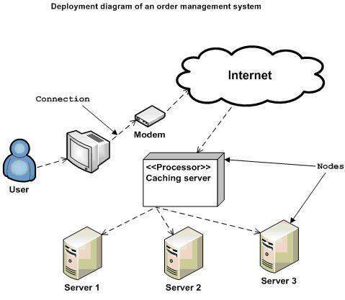

**Chapter 7**

**Software Implementation**

**7.1 Modules of Find Doctor website:**

A software system is always divided into several sub systems that makes it easier for  the development. A software system that is structured into several subsystems makes it easy  for the development and testing. The different subsystems are known as the modules and the  process of dividing an entire system into subsystems is known as modularization or  decomposition.

A system cannot be decomposed into several subsystems in any way. There must some  logical barrier, which facilitates the separation of each module. The separation must be  simple but yet must be effective so that the development is not affected. **Two main modules are:-**

1. **Administrator**
2. **Student**
   1. **Role in the project:**

Our project title is SchoolQuest website. We are designing a project in a PHP language and use My SQL as database and use Rational Rose as a tool. We are a Two member in our  Project Palak Sharma ,Jyoti Gaji…. are work as a designer and project report Project Palak Sharma ,Jyoti Gaji work as a Database designer and.Shiwani Punjabi work as a  coding.

**Chapter 8**

**Software Testing**

**8.1 Testing Objectives**

In this project testing is performed to check whether the system is working, properly trainedand able to provide the correct directions for a selected region as per user demand. For this purpose different modules are tested differently.

**Testing Scope**

In this project, we need to understand the features that are to be tested. Out of everything that could be tested we have selected the right features to test and the right techniques to test them. We have detailed the testing processes which are being used.

**Testing Principles**

Before applying methods to design effective test cases, it is necessary to understand the basic principles that guide software testing.

**a**. All tests should be traceable to customer’s requirements: It follows that the

most severe defects are those that cause the program to fail to meet its requirements.

**b**. Tests should be planned long before testing begins: ​Test planning can begin as

soon as the requirements model is complete. Detailed definition of test cases can

begin as soon as the design model has been solidified.

**c**. The Pareto principle applies to software testing: Stated simply, the Pareto

principle implies that 80 percent of all errors uncovered during testing will likely be traceable to 20 percent of all program components. The problem, of course, is to isolate these suspect components and to thoroughly test them.

**d**. Testing should begin “in the small” and progress toward testing “in the

large”: ​The first tests planned and executed generally focuses on individual

components. As testing progresses the focus shifts in an attempt to find errors in

integrated clusters of components and ultimately in the entire system.

**e**. Exhaustive testing is not possible: ​The number of path permutations for even a

moderately sized program is exceptionally large. For this reason, it is impossible to execute every combination of paths during testing. It is possible, however, to

adequately cover program logic and to ensure that all conditions in the

component-level design have been exercised.

**8.2 Types of Testing**

The testing approach we followed is Unit testing along with Integration and Validationtesting.

a. **Unit testing**: ​Unit testing focus on the individual modules of the project. It is white box oriented and can be conducted in parallel for multiple components. Following are the modules we tested individually to ensure that the information properly flows in and out of the program unit.

· Interactive GUI: ​Test the various inputs given by the user.

· Acronyms Expansion: ​Test if the acronyms are replaced in entered tweets.

b. **Integration Testing**: ​Integration testing tests integration or interfaces between

components, interactions to different parts of the system such as an operating system, file system and hardware or interfaces between systems. Integration testing is done by a specific integration tester or test team. Integration testing follows two approaches known as “Top Down” approach and “Bottom Up” approach.

c. **Validation Testing**: ​Validation is done at the end of the development process andtakes place after verifications are completed. Determining is the system complieswith the requirements and performs functions for which it is intended and meets theorganization’s goals and user needs.

d. **Black Box Testing**: ​Black box testing is a software testing technique in which

functionality of the software under test (SUT) is tested without looking at the internal code structure, implementation details and knowledge of internal paths of the software. This type of testing is based entirely on the software requirements and specifications.

e. **White box Testing**: ​White box testing is the testing of a software solution’s

internal coding and infrastructure. It focuses primarily on strengthening security, the flow of inputs and outputs through the application, and improving design and

usability. White box testing is also known as clear, open, structural testing.

**Chapter – 9**

**ScreenShot : Front End Design**

**1.Home Page**

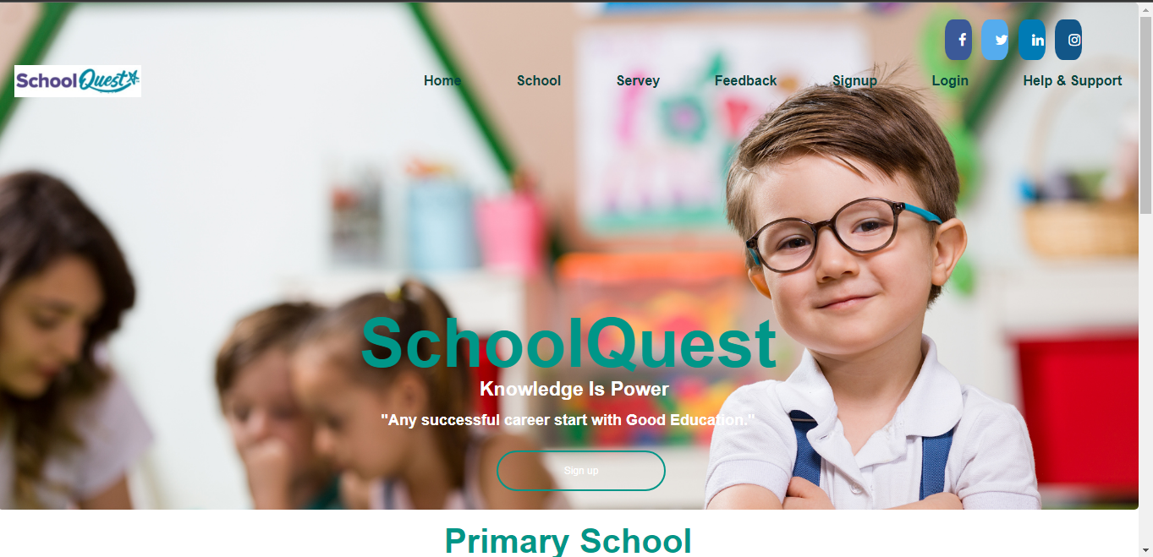

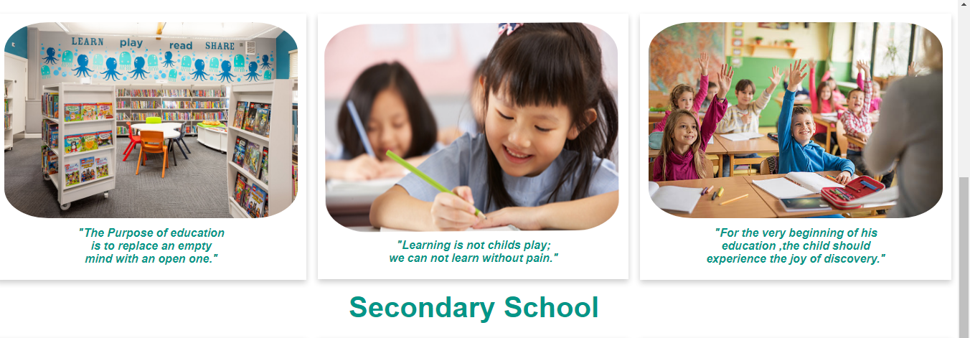

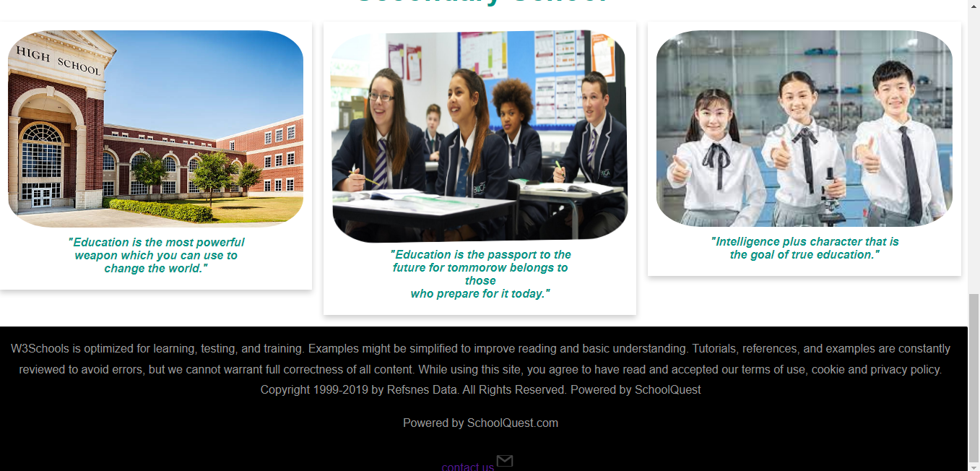

**2. Schools page**

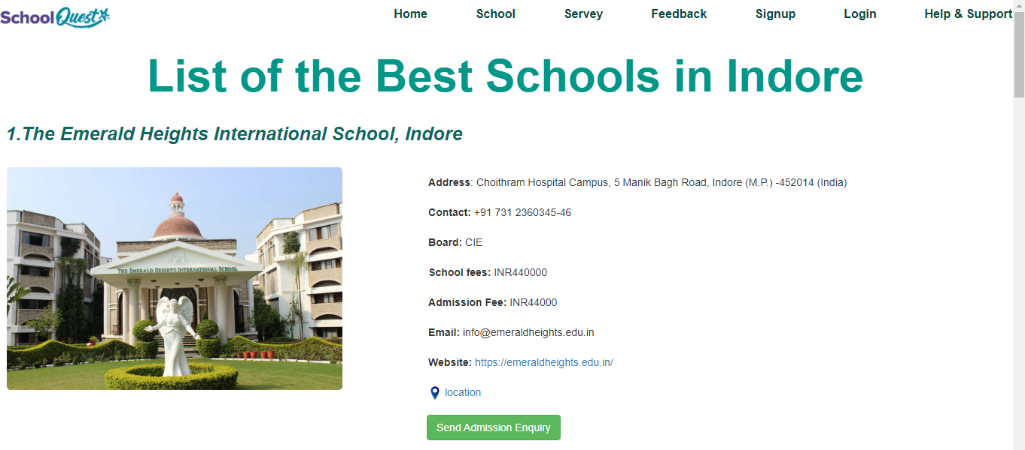

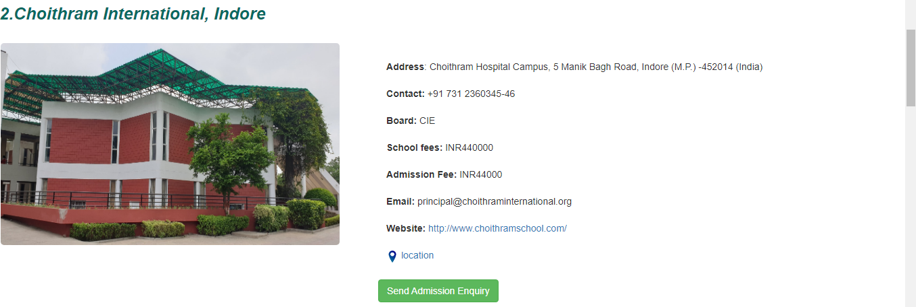

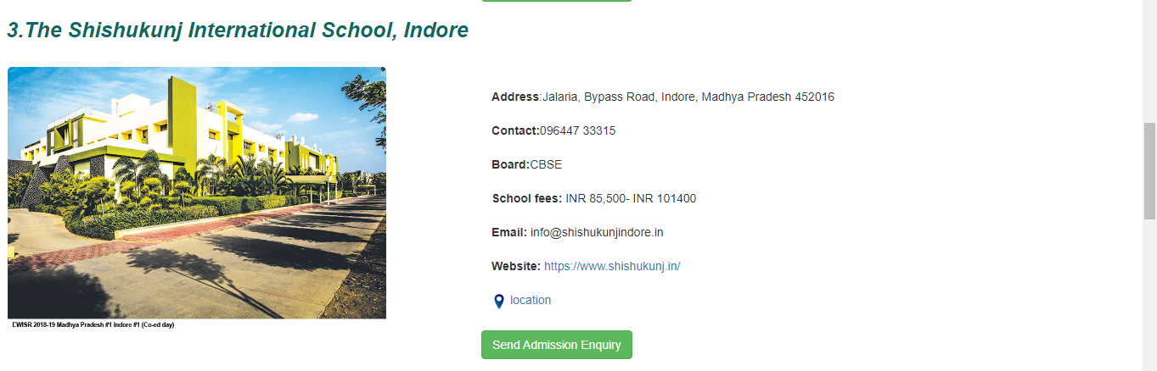

**3.Survey page**

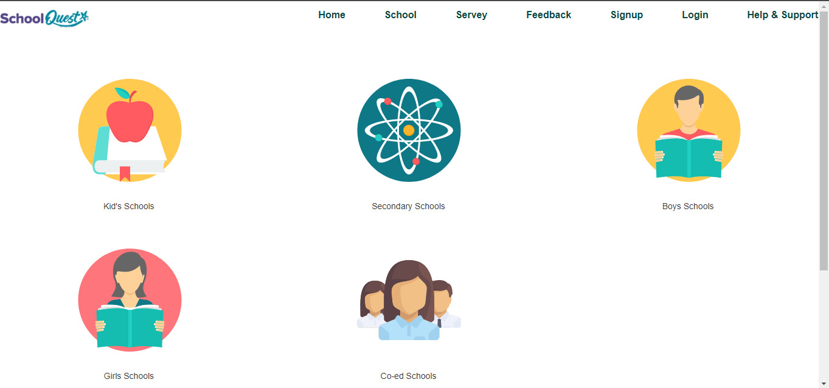

**4. Kids School Page**

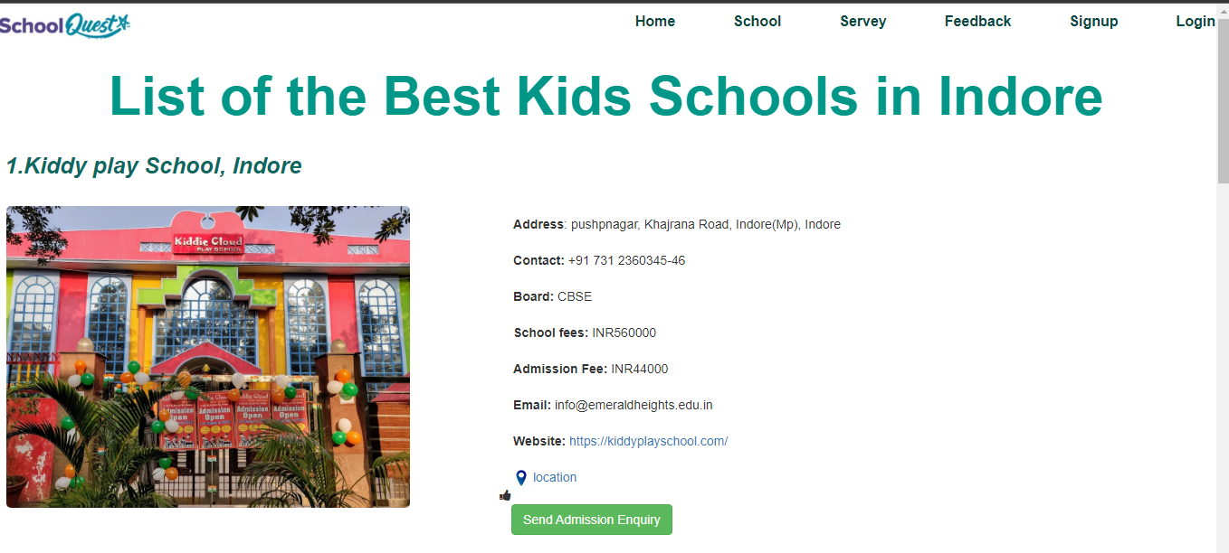

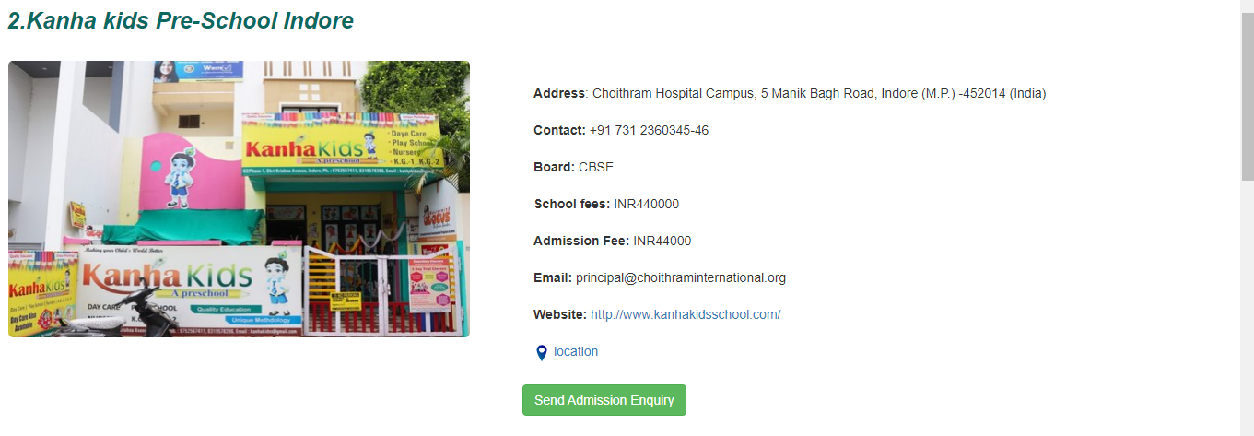

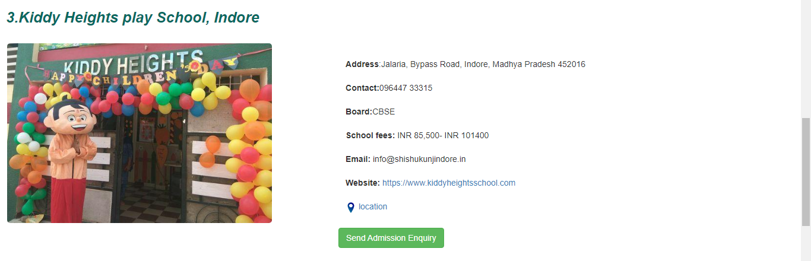

**Secondary School Page**

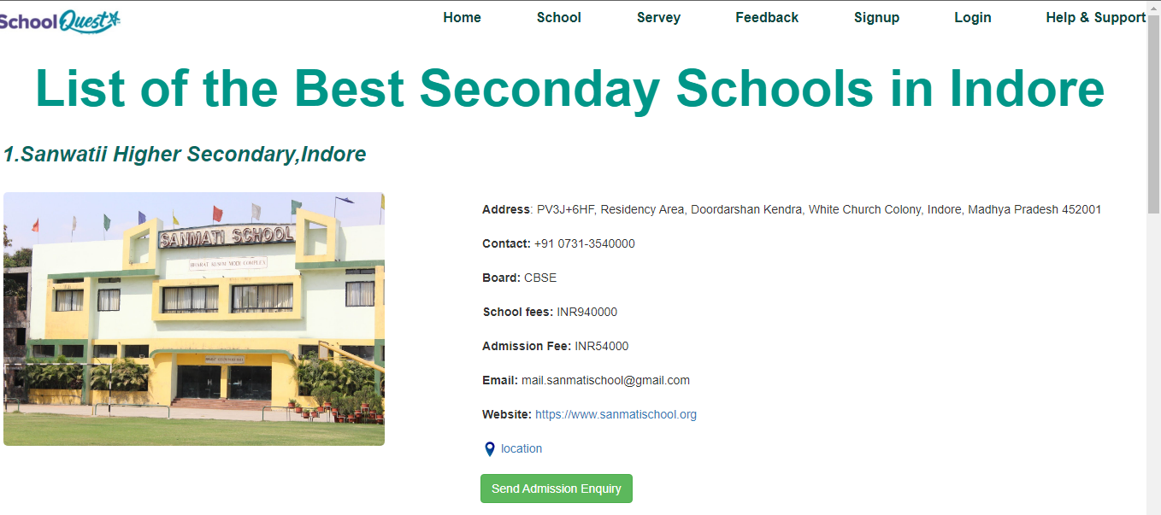

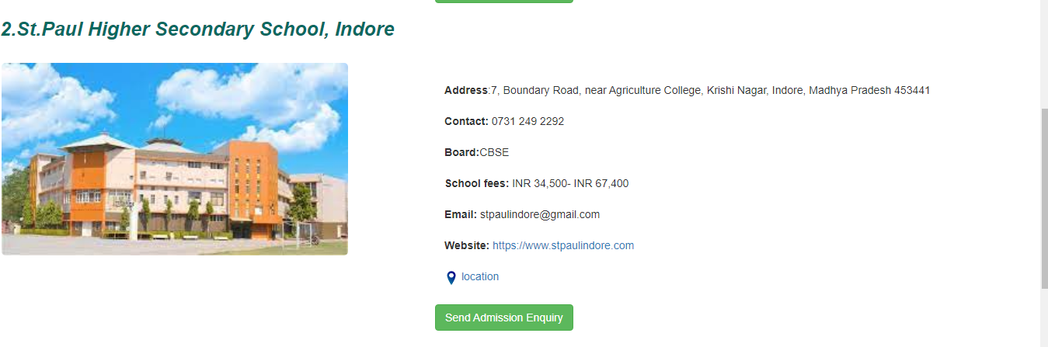

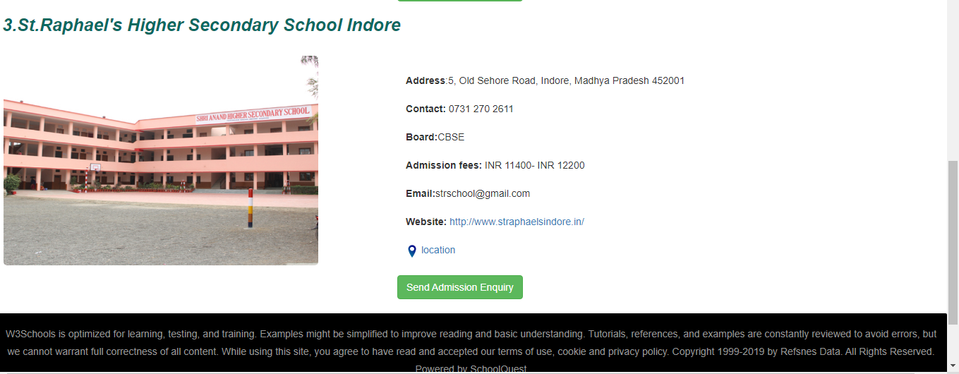

**Boy’s School Page**

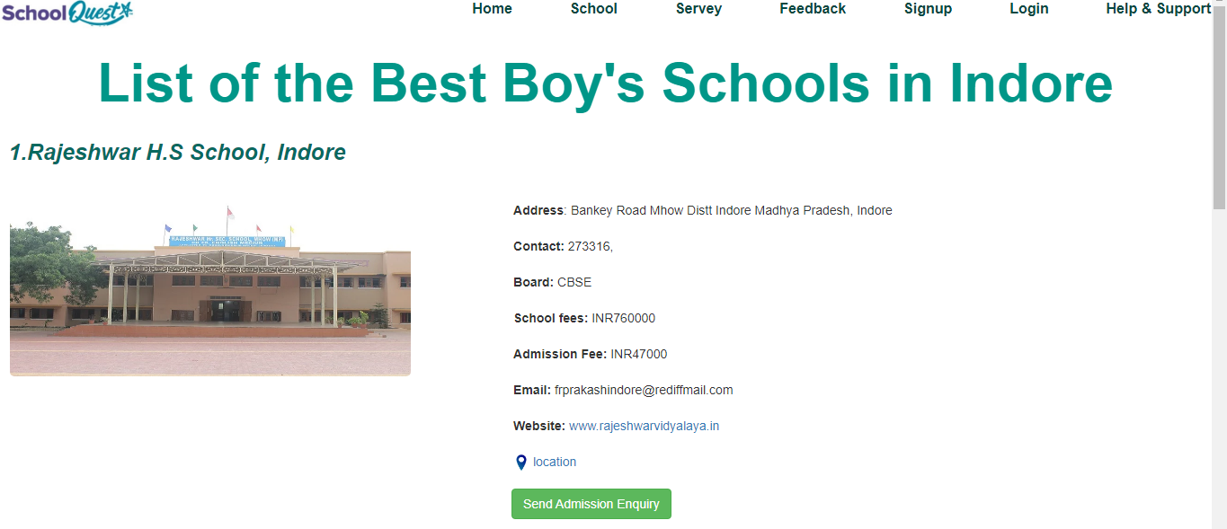

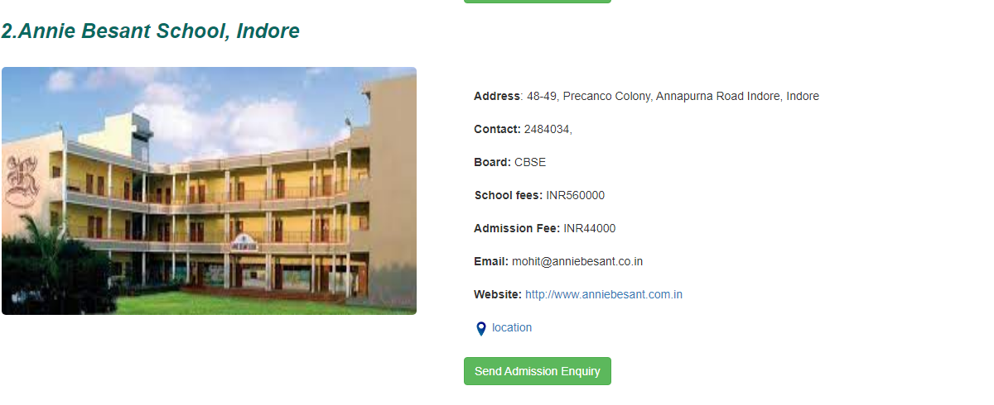

**Girl’s School Page**

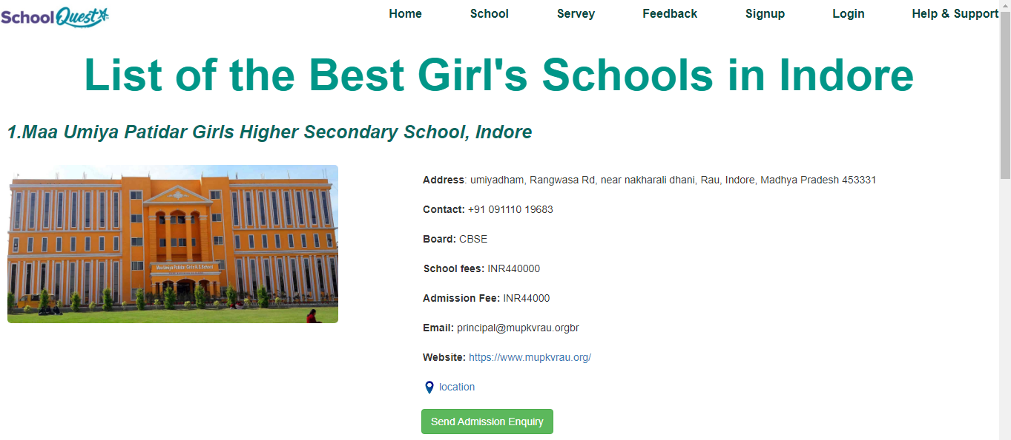

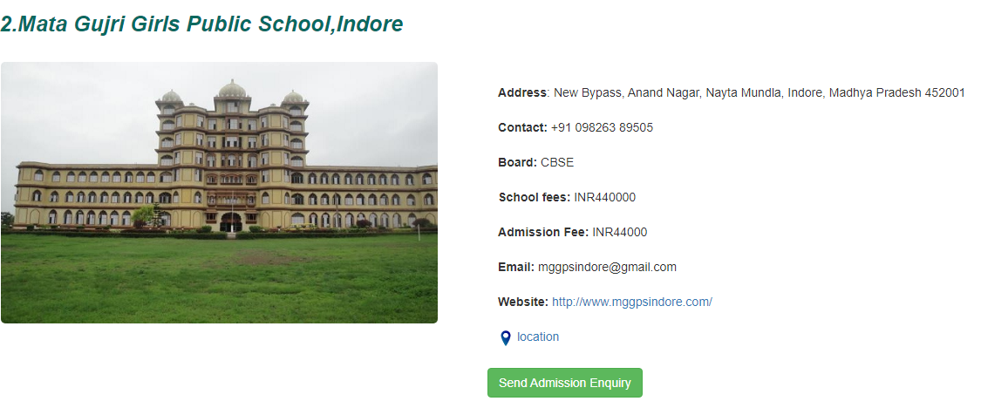

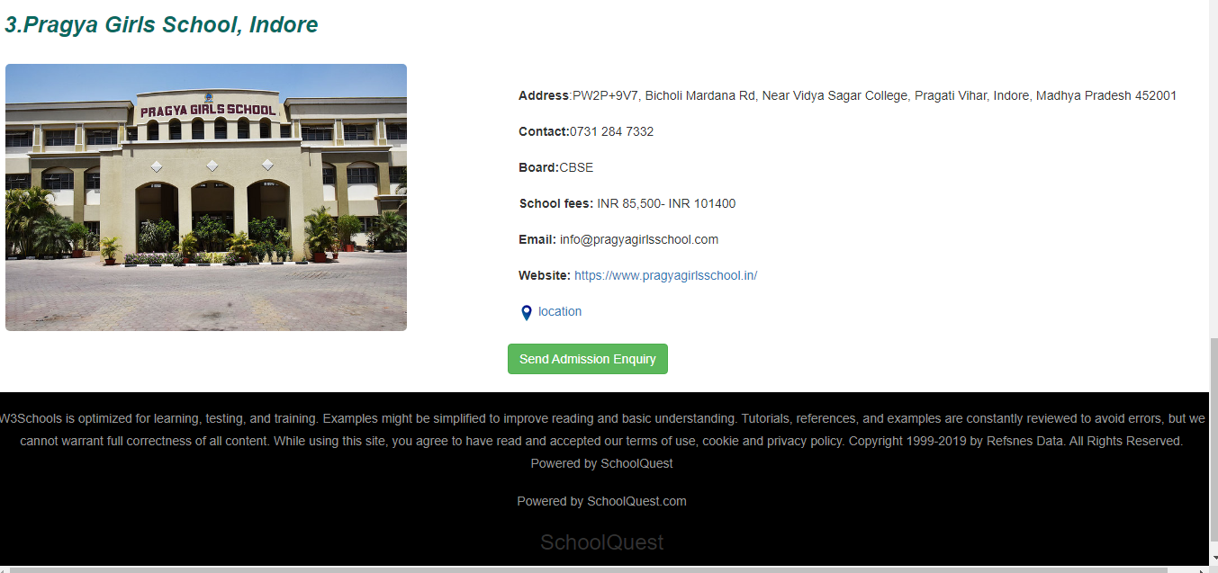

**Co-ed School Page**

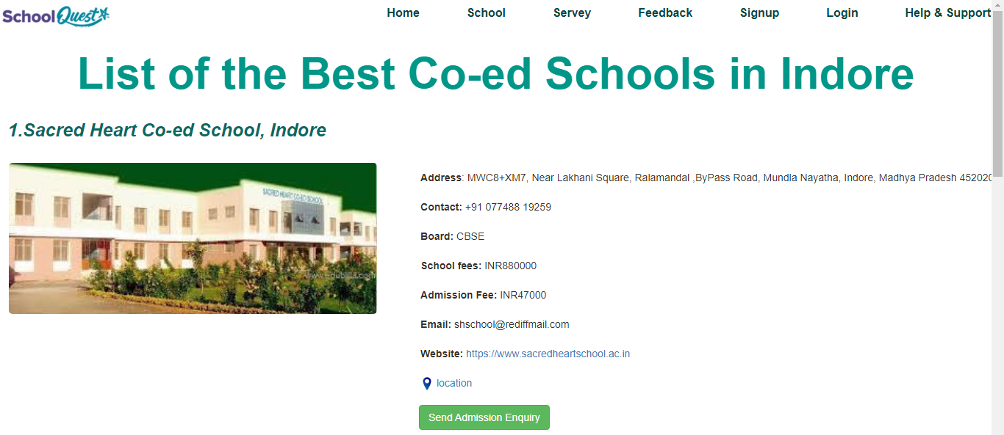

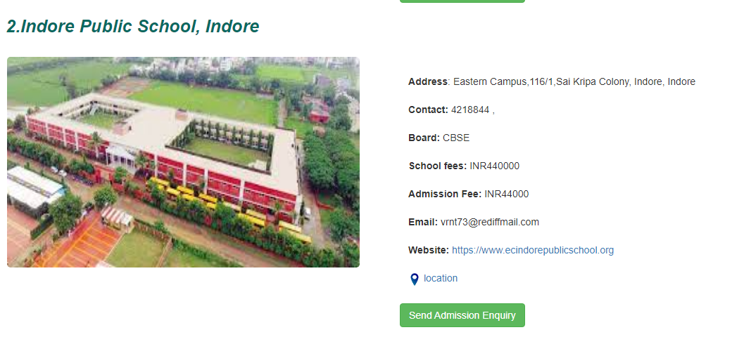

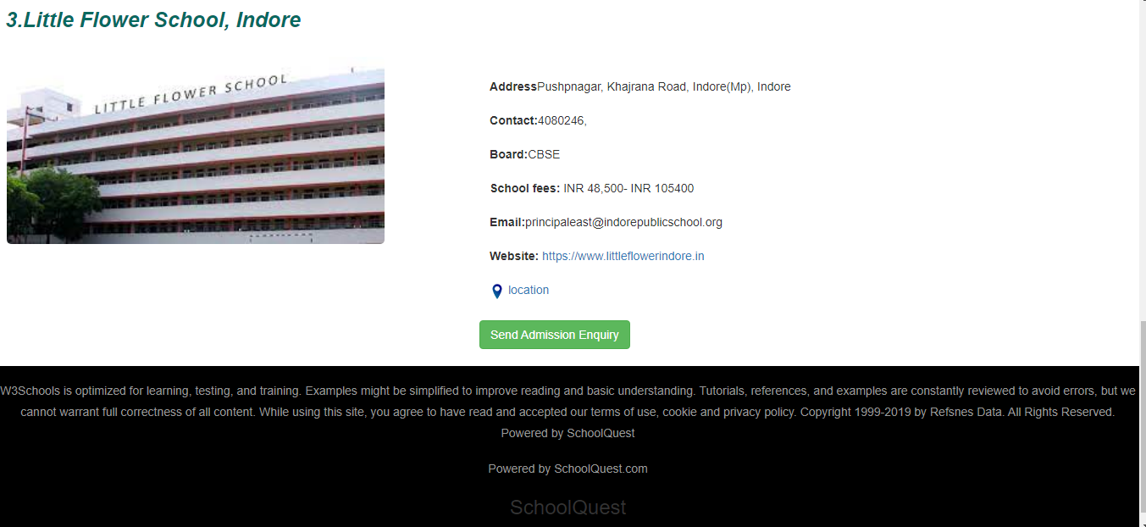

**4. Feedback Page**

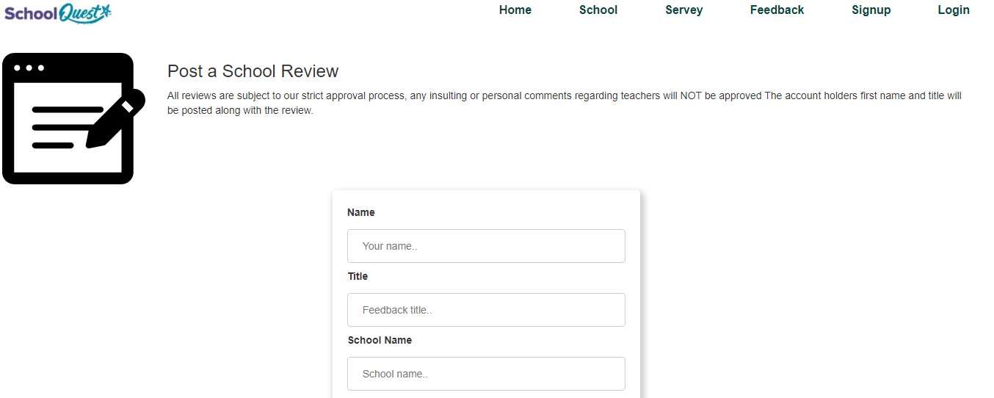

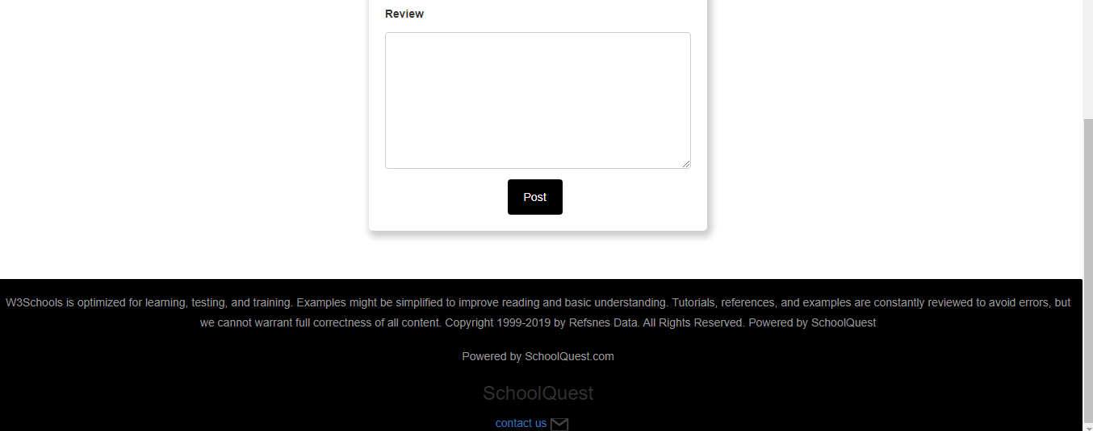

**5. Sign up Page**

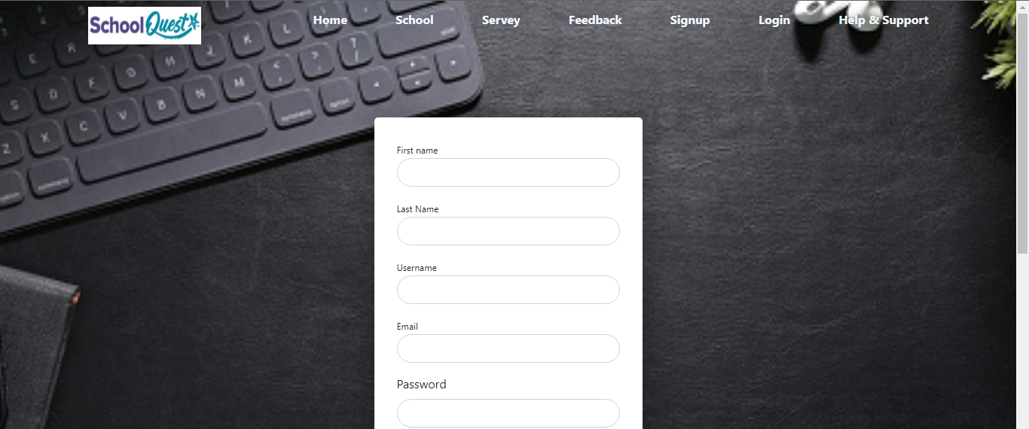



**6. Login Page**

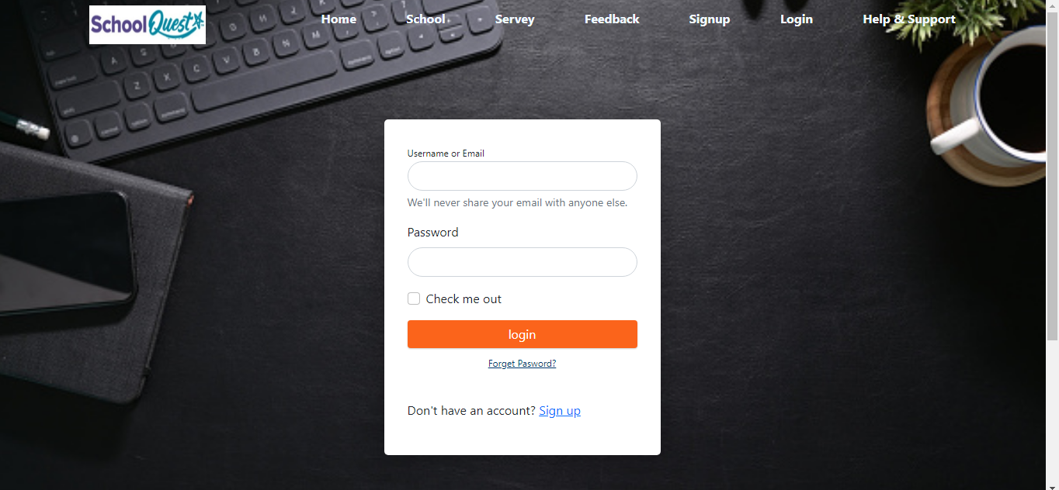





**7. Help & Support Page**

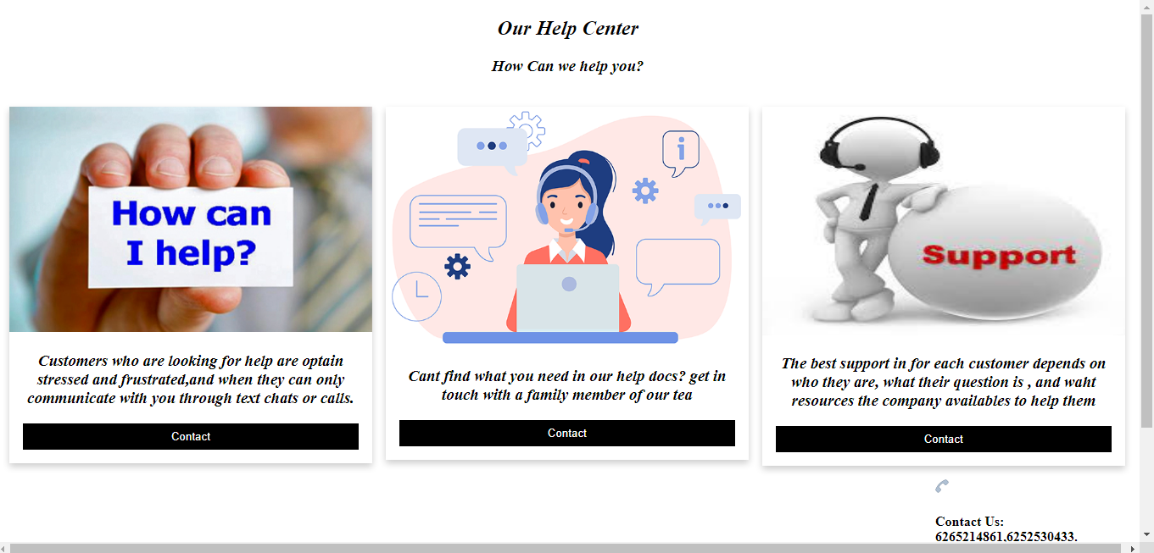

**Chapter 10**

**DataBase Tables (ScreenShots)**

**Feedback Table**

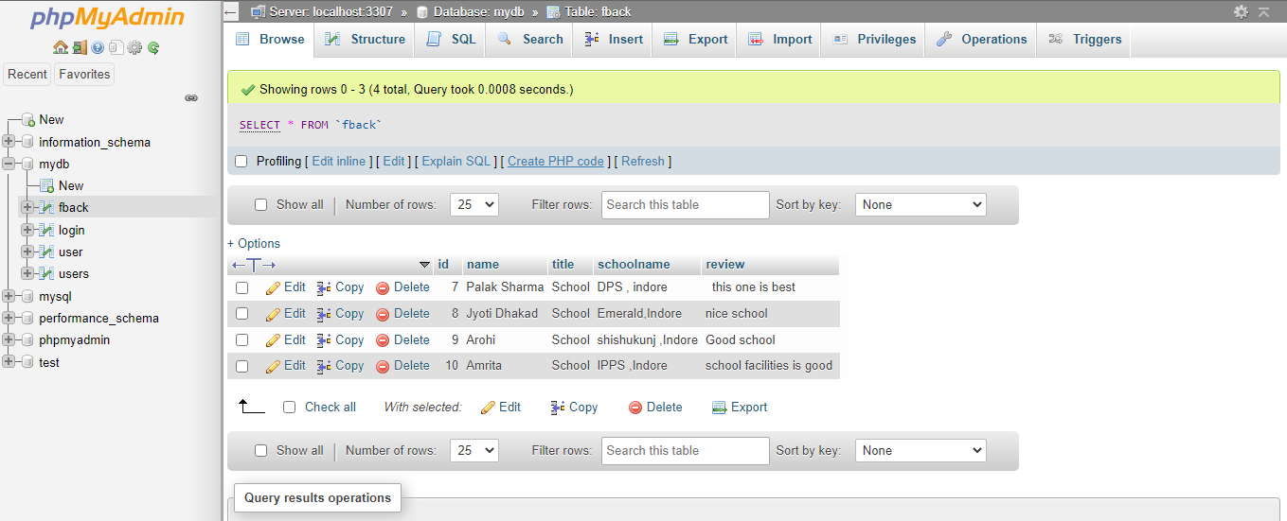

**Chapter : 9 Coding**

**9.1 Html code**

**Home page**

<!DOCTYPE html>

<html>

<head>

    <meta name="viewport" contemt="width=device-width,  initial-scale=1.0">

    <title>website design - SchoolQuest</title>

    <link rel="stylesheet" type="text/css" href="main2.css">

    <link rel="stylesheet" type="text/css" href="nav.css">

    <link rel="stylesheet" type="text/css" href="css/form.css">

    <link href="https://font.googleapis.com/css2?

    family=Roboto:wght@400;700&display=swap" rel="stylesheet">

    <link rel="stylesheet" href="https://cdnjs.cloudflare.com/ajax/libs/font-awesome/4.7.0/css/font-awesome.min.css">

    <style>

        #w {

            display: block;

        }

        #y {

            position: fixed;

        }

    </style>

</head>

<body>

    <div class="container">

        <a href="#" class="fa fa-facebook"></a>

        <a href="#" class="fa fa-twitter"></a>

        <a href="#" class="fa fa-linkedin"></a>

        <a href="#" class="fa fa-instagram"></a><br>

        <div class="navbar">

            <img src="images/logo.jpg" class="logo">

            <nav>

                <ul>

                    <li><a href="index1.html">Home</a></li>

                    <li><a href="schools.html">School</a></li>

                    <li><a href="servey.html">Servey</a></li>

                    <li><a href="feedback.html">Feedback</a></li>

                    <li><a href="signup.php">Signup</a></li>

                    <li><a href="login.html">Login</a></li>

                    <li><a href="help.html">Help & Support</a></li>

                </ul>

            </nav>

        </div>

        <div class="row2">

            <div class="col">

                <h1> SchoolQuest</h1>

            </div>

            <div class="col">

                <p> <strong>Knowledge Is Power</strong></p><br>

                <h3 class="h3">"Any successful career start with Good Education."</h3>

                <button class="button" onclick="document.getElementById('w').style.display = 'block'">Sign

                    up</button>

            </div>

        </div>

    </div>

    </div>

    <h2>Primary School</h2>

    <div class="row1">

        <div class="column">

            <div class="card">

                <img src="images/primary1.jpg" alt="Jane" style="width:100%" class="imgshake"  >

                <div class="container1">

                    <h4>"The Purpose of education <br>is to replace an empty<br> mind with an open one." </h4>

                </div>

            </div>

        </div>

        <div class="column">

            <div class="card">

                <img src="images/img7.jpg" alt="Mike" style="width:100%"  height="290px"class="imgshake">

                <div class="container1">

                    <h4>"Learning is not childs play;<br> we can not

                        learn without pain."

                    </h4>

                </div>

            </div>

        </div>

        <div class="column">

            <div class="card">

                <img src="images/primay3.jpg" alt="John" style="width:100%" class="imgshake">

                <div class="container1">

                    <h4>"For the very beginning of his education ,the child should<br> experience the joy of discovery."

                    </h4>

                </div>

            </div>

        </div>

    </div>

    </div>

    <h2>Secondary School</h2>

    <div class="row1">

        <div class="column">

            <div class="card">

                <img src="images/secondary1.jpg" alt="Jane" style="width:100%" class="imgshake">

                <div class="container1">

                    <h4>"Education is the most powerful weapon which you can use to<br> change the world."</h4>

                </div>

            </div>

        </div>

        <div class="column">

            <div class="card">

                <img src="images/secondary2.jpg" alt="Mike" style="width:100% " height="290px" class="imgshake">

                <div class="container1">

                    <h4>"Education is the passport to the<br> future for tommorow belongs to those<br> who prepare for it today."

                    </h4>

                </div>

            </div>

        </div>

        <div class="column">

            <div class="card">

                <img src="images/img2.jpg" alt="John" style="width:100%" class="imgshake">

                <div class="container1">

                    <h4>"Intelligence plus character that is the goal of true education."</h4>

                </div>

            </div>

        </div>

    </div>

    <div class="row">

        <div class="col-sm-12 head">

            <p class="foot">

                W3Schools is optimized for learning, testing, and training. Examples might be simplified to improve

                reading and

                basic understanding. Tutorials, references, and examples are constantly reviewed to avoid errors,

                but we cannot

                warrant full correctness of all content. While using this site, you agree to have read and accepted

                our terms of

                use, cookie and privacy policy. Copyright 1999-2019 by Refsnes Data. All Rights Reserved.

                Powered by SchoolQuest</p>

            <p class="foot">Powered by SchoolQuest.com</p>

            <h3 style="text-align:center">SchoolQuest</h3>

            <span style="margin-left:46%"><a href="">contact us<img src="images/gmail.svg" width=30px

                        heigth=30px></a><span>

**Schools page**

<!DOCTYPE html>

<html lang="en">

<head>

  <title>Schools</title>

  <meta charset="utf-8">

  <meta name="viewport" content="width=device-width, initial-scale=1">

  <link rel="stylesheet" href="css/bootstrap.min.css">

  <script src="css/jquery.min.js"></script>

  <script src="angular.min.js"></script>

  <script src="css/bootstrap.min.js"></script>

  <link rel="stylesheet" type="text/css" href="school.css">

  <link rel="stylesheet" type="text/css" href="css/form.css">

  <script src="js/addons/rating.js"></script>

  <link rel="stylesheet" href="https://cdnjs.cloudflare.com/ajax/libs/font-awesome/4.7.0/css/font-awesome.min.css">

</head>

<body>

  <div class="navbar">

    <img src="images/logo.jpg" class="logo">

    <nav>

      <ul>

        <li><a href="index1.html" class="anc">Home</a></li>

        <li><a href="schools.html" class="anc">School</a></li>

        <li><a href="servey.html" class="anc">Servey</a></li>

        <li><a href="feedback.html" class="anc">Feedback</a></li>

        <li><a href="signup.php" class="anc">Signup</a></li>

        <li><a href="login.html" class="anc"> Login</a></li>

        <li><a href="help.html">Help & Support</a></li>

      </ul>

    </nav>

  </div>

  <div class="row ">

    <h1 style="display: block" ;><b>List of the Best Schools in Indore</b></h1>

    <div class="row shadow schoolDiv">

      <h2><b>1.The Emerald Heights International School, Indore</b></h2><br>

      <div class="col-sm-5"><img height="50%" width="80%" style=" border-radius: 5px; margin-left: 27px;"

          src="images/emerald.jpg" />

        <span id="rateMe2" class="empty-stars"></span>

      </div>

      <div class="col-sm-7" style="padding-top: 10px; ">

<b> Address</b>: Choithram Hospital Campus, 5 Manik Bagh Road, Indore (M.P.) -452014 (India)<br><br>

        <b>Contact:</b> +91 731 2360345-46<br><br>

        <b>Board:</b> CIE<br><br>

        <b>School fees:</b> INR440000<br><br>

        <b>Admission Fee:</b> INR44000<br><br>

        <b>Email:</b> info@emeraldheights.edu.in<br><br>

        <b>Website:</b> <a href="https://emeraldheights.edu.in/">https://emeraldheights.edu.in/</a> <br><br>

        <img src="pin.png" height="18px"><a

          href="https://www.google.co.in/maps/place/The+Emerald+Heights+International+School/@22.6507966,75.8174433,17z/data=!3m1!4b1!4m5!3m4!1s0x3962fc081a1e5019:0xeb41f73ed85b2d71!8m2!3d22.6508005!4d75.819652">

          location</a>

      </div></br></br>

      <div class="like">

        <script>function myFunction(x) {

            x.classList.toggle("fa-thumbs-down");

          }</script>

        <i onclick="myFunction(this)" class="fa fa-thumbs-up" width="100%"></i>

      </div>

      <div class="ad"> <a class="btn btn-success" href="https://emeraldheights.edu.in/" role="button">Send Admission

          Enquiry</a></div>

    </div>

**Survey Page**

<!DOCTYPE html>

<html lang="en">

<head>

  <title>survey</title>

  <meta charset="utf-8">

  <meta name="viewport" content="width=device-width, initial-scale=1">

  <link rel="stylesheet" href="css/bootstrap.min.css">

  <script src="css/jquery.min.js"></script>

  <script src="angular.min.js"></script>

  <script src="css/bootstrap.min.js"></script>

  <link rel="stylesheet" type="text/css" href="css/main.css">

  <link rel="stylesheet" type="text/css" href="css/form.css">

  <link rel="stylesheet" type="text/css" href="school.css">

</head>

<body>

  <div class="navbar">

    <img src="images/logo.jpg" class="logo">

    <nav>

      <ul>

        <li><a href="index1.html" class="anc">Home</a></li>

        <li><a href="schools.html" class="anc" >School</a></li>

        <li><a href="servey.html" class="anc">Servey</a></li>

        <li><a href="feedback.html" class="anc">Feedback</a></li>

        <li><a href="signup.php" class="anc">Signup</a></li>

        <li><a href="login.html" class="anc"> Login</a></li>

        <li><a href="help.html">Help & Support</a></li>

      </ul>

    </nav>

  </div>

    </br></br>

    <div class="row">

      <div class="col-sm-4">

        <div class="dot"><a href="#"> <img src="images/owl.svg" class="imgDot"></a> </div>

        <p style="text-align:center;">Kid's Schools</p>

      </div>

      <div class="col-sm-4">

        <div class="dot"><a href="#"> <img src="images/physics.svg" class="imgDot"> </a> </div>

        <p style="text-align:center;">Secondary Schools</p>

      </div>

      <div class="col-sm-4">

        <div class="dot"><a href="#"> <img src="images/reading.svg" class="imgDot"> </a></div>

        <p style="text-align:center;">Boys Schools</p>

      </div>

    </div>

    </br></br>

    <div class="row">

      <div class="col-sm-4">

        <div class="dot"> <a href="#"><img src="images/learning.svg" class="imgDot"> </a></div>

        <p style="text-align:center;">Girls Schools</p>

      </div>

      <div class="col-sm-4">

        <div class="dot"><a href="#"><img src="images/network.svg" class="imgDot"> </a></div>

        <p style="text-align:center;">Co-ed Schools</p>

      </div>

    </div>

    </br> </br>

    <div class="row">

      <div class="col-sm-12 head">

        <p class="foot">

          W3Schools is optimized for learning, testing, and training. Examples might be simplified to improve reading

          and basic understanding. Tutorials, references, and examples are constantly reviewed to avoid errors, but we

          cannot warrant full correctness of all content. While using this site, you agree to have read and accepted our

          terms of use, cookie and privacy policy. Copyright 1999-2019 by Refsnes Data. All Rights Reserved.

          Powered by SchoolQuest</p>

        <p class="foot">Powered by SchoolQuest.com</p>

</body>

</html>

**Feedback page**

<!DOCTYPE html>

<html lang="en">

<head>

  <title>feedback</title>

  <meta charset="utf-8">

  <meta name="viewport" content="width=device-width, initial-scale=1">

  <link rel="stylesheet" href="css/bootstrap.min.css">

  <script src="css/jquery.min.js"></script>

  <script src="angular.min.js"></script>

  <script src="css/bootstrap.min.js"></script>

  <link rel="stylesheet" type="text/css" href="school.css">

  <link rel="stylesheet" type="text/css" href="css/form.css">

</head>

<body>

  <div class="container-fluid">

    <div class="navbar">

      <img src="images/logo.jpg" class="logo">

      <nav>

        <ul>

          <li><a href="index1.html" class="anc">Home</a></li>

          <li><a href="schools.html" class="anc">School</a></li>

          <li><a href="servey.html" class="anc">Servey</a></li>

          <li><a href="feedback.html" class="anc">Feedback</a></li>

          <li><a href="signup.php" class="anc">Signup</a></li>

          <li><a href="login.html" class="anc"> Login</a></li>

        </ul>

      </nav>

    </div>

    <div class="row">

      <div class="col-sm-2"> <img src="images/survey.svg" class="imgDot"></div>

      <div class="col-sm-10">

        <h3>Post a School Review</h3>

        <p>

          All reviews are subject to our strict approval process, any insulting or personal comments regarding teachers

          will NOT be approved

          The account holders first name and title will be posted along with the review.

        </p>

      </div>

    </div>

    <div class="row">

      <div class="col-sm-4"></div>

      <div class="col-sm-4">

        <div class="shadowForm">

          <form action="feedback.php" method="POST">

            <label for="name">Name</label>

            <input type="text" id="name" name="name" placeholder="Your name..">

        <label for="title">Title</label>

            <input type="text" id="title" name="title" placeholder="Feedback title..">

            <label for="schoolname">School Name</label>

            <input type="text" id="schoolname" name="schoolname" placeholder="School name..">

            <label for="review">Review</label>

            <textarea id="textarea" name="review">

    </textarea>

            <input type="submit" value="Post" style="margin-left:40%;background-color:black;">

          </form>

        </div>

      </div>

      <div class="col-sm-4"></div>

    </div>

    </br></br>

    </br>

  </div>

</body>

</html>

**Login page**

<!DOCTYPE html>

<html>

<head>

  <title>login</title>

  <link href="https://cdn.jsdelivr.net/npm/bootstrap@5.0.2/dist/css/bootstrap.min.css" rel="stylesheet">

  <link rel="stylesheet" type="text/css" href="style.css">

  <link rel="stylesheet" type="text/css" href="school.css">

  <style>

    .nav-item{

    color: aliceblue;

    }

</style>

</head>

<body style="background: url('login2.jpg'); background-repeat: no-repeat; background-position: center;

  background-size: cover; height:600px;">

  <div class="container">

    <div class="navbar">

      <img src="images/logo.jpg" class="logo">

      <nav>

          <ul>

              <li><a  class="nav-item" href="index1.html">Home</a></li>

              <li><a  class="nav-item"href="schools.html">School</a></li>

              <li><a  class="nav-item"href="servey.html">Servey</a></li>

              <li><a  class="nav-item"href="feedback.html">Feedback</a></li>

              <li><a  class="nav-item"href="signup.php">Signup</a></li>

              <li><a  class="nav-item"href="login.html">Login</a></li>

              <li><a  class="nav-item"href="help.html">Help & Support</a></li>

          </ul>

      </nav>

  </div>

    <div class="row">

      <div class="col-sm-4">

      </div>

      <div class="col-sm-4">

        <div class="login_form">

          <form action="login1.php" method="post">

            <div class="mb-3">

              <label class="label_txt">Username or Email</label>

              <input type="email" class="form-control" id="username" name="username" aria-describedby="emailHelp">

              <div id="emailHelp" class="form-text">We'll never share your email with anyone else.</div>

            </div>

            <div class="mb-3">

              <label for="exampleInputPassword1" class="form-label">Password</label>

              <input type="password" class="form-control" id="Password" name="password">

            </div>

            <div class="mb-3 form-check">

              <input type="checkbox" class="form-check-input" id="exampleCheck1">

              <label class="form-check-label" for="exampleCheck1">Check me out</label>

            </div>

            <button type="submit" class=" form_btn btn btn-primary">login</button>

          </form>

          <p style="font-size: 12px;text-align: center;margin-top: 10px;">

            <a href="#" style="color: #00376b;">Forget Pasword?</a>

          </p>

          <br>

          <p>Don't have an account? <a href="signup.php">Sign up</a></p>

        </div>

      </div>

      <div class="col-sm-4">

      </div>

    </div>

  </div>

</body>

<br>

<br>

<br>

<br>

<br>

<div class="row">

  <div class="col-sm-12 head">

    <p class="foot">

      W3Schools is optimized for learning, testing, and training. Examples might be simplified to improve reading and

      basic understanding. Tutorials, references, and examples are constantly reviewed to avoid errors, but we cannot

      warrant full correctness of all content. Copyright 1999-2019 by Refsnes Data. All Rights Reserved.

      Powered by SchoolQuest</p>

    <p class="foot">Powered by SchoolQuest.com</p>

    <h3 style="text-align:center">SchoolQuest</h3>

    <span style="margin-left:46%"><a href="">contact us<img src="images/gmail.svg" width=30px heigth=30px></a><span>

  </div>

</div>

</div>

<script src="https://cdn.jsdelivr.net/npm/bootstrap@5.0.2/dist/js/bootstrap.bundle.min.js"></script>

</html>

**Signup Page**

<!DOCTYPE html>

<html>

<head>

    <title>Sign Up</title>

    <link href="https://cdn.jsdelivr.net/npm/bootstrap@5.0.2/dist/css/bootstrap.min.css" rel="stylesheet">

    <link rel="stylesheet" type="text/css" href="style.css">

    <link rel="stylesheet" type="text/css" href="school.css">

    <style>

        .nav-item {

            color: aliceblue;

        }

    </style>

</head>

<body style="background: url('login2.jpg'); background-repeat: no-repeat; background-position: center;

  background-size: cover; height:900px;">

    <div class="container">

        <div class="navbar">

            <img src="images/logo.jpg" class="logo">

            <nav>

                <ul>

                    <li><a class="nav-item" href="index1.html">Home</a></li>

                    <li><a class="nav-item" href="schools.html">School</a></li>

                    <li><a class="nav-item" href="servey.html">Servey</a></li>

                    <li><a class="nav-item" href="feedback.html">Feedback</a></li>

                    <li><a class="nav-item" href="signup.php">Signup</a></li>

                    <li><a class="nav-item" href="login.html">Login</a></li>

                    <li><a class="nav-item" href="help.html">Help & Support</a></li>

                </ul>

            </nav>

        </div>

        <div class="row">

            <div class="col-sm-4">

            </div>

            <div class="col-sm-4">

                <div class="login_form">

                    <form action="login1.php" method="post">

                        <div class="mb-3">

                            <label class="label_txt">First name</label>

                            <input type="text" class="form-control" id="firstname" name="firstname"

                                aria-describedby="emailHelp">

                        </div>

                        <div class="mb-3">

                            <label class="label_txt">Last Name</label>

                            <input type="text" class="form-control" id="lastname" name="lastname"

                                aria-describedby="emailHelp">

                        </div>

                        <div class="mb-3">

                            <label class="label_txt">Username </label>

                            <input type="text" class="form-control" id="username" name="username"

                                aria-describedby="emailHelp">

                        </div>

                        <div class="mb-3">

                            <label class="label_txt"> Email</label>

                            <input type="email" class="form-control" id="email" name="email"

                                aria-describedby="emailHelp">

                        </div>

                        <div class="mb-3">

                            <label for="exampleInputPassword1" class="form-label">Password</label>

                            <input type="password" class="form-control" id="Password" name="password">

                        </div>

                        <div class="mb-3">

                            <label for="exampleInputPassword1" class="form-label"> ConfirmPassword</label>

                            <input type="password" class="form-control" id="confirmPassword" name="confirmpassword">

                        </div>

                        <div class="mb-3 form-check">

                            <input type="checkbox" class="form-check-input" id="exampleCheck1">

                            <label class="form-check-label" for="exampleCheck1">Check me out</label>

                        </div>

                        <button type="submit" class=" form_btn btn btn-primary">login</button>

                    </form>

                    <p style="font-size: 12px;text-align: center;margin-top: 10px;">

                        <a href="#" style="color: #00376b;">Forget Pasword?</a>

                    </p>

                    <br>

                    <p>Don't have an account? <a href="signup.php">Sign up</a></p>

                </div>

            </div>

            <div class="col-sm-4">

            </div>

        </div>

    </div>

    <button onclick="myFunction()">Try it</button>

    <script>

        function myFunction() {

            alert("I am an alert box!");

        }

    </script>

</body>

<br>

<br>

<br>

<br>

<br>

<div class="row">

    <div class="col-sm-12 head">

        <p class="foot">

            W3Schools is optimized for learning, testing, and training. Examples might be simplified to improve reading

            and

            basic understanding. Tutorials, references, and examples are constantly reviewed to avoid errors, but we

            cannot

            warrant full correctness of all content. Copyright 1999-2019 by Refsnes Data. All Rights Reserved.

            Powered by SchoolQuest</p>

        <p class="foot">Powered by SchoolQuest.com</p>

        <h3 style="text-align:center">SchoolQuest</h3>

        <span style="margin-left:46%"><a href="">contact us<img src="images/gmail.svg" width=30px heigth=30px></a><span>

    </div>

</div>

</div>

<script src="https://cdn.jsdelivr.net/npm/bootstrap@5.0.2/dist/js/bootstrap.bundle.min.js"></script>

   *{ margin: 0;

    padding: 0;

    font-family: 'Roboto' , sans-serif;

}

.container{

    width: 100%;

    height: 100vh;

    background-image: url('../images/img5.jpg');

    background-position: center;

    background-size: cover;

    padding-left: 8%;

    padding-right: 8%;

    box-sizing: border-box;

}

.navbar{

    height: 9%;

    display: flex;

    align-items: center;

}

.logo{

    margin-top: 10px;

    width: 100px;

    margin-left: 2px

    cursor: pointer;

}

.menu-icon{

    width: 30px;

    cursor: pointer;

    margin-left: 40px;

}

nav{

    flex: 1;

    text-align: right;

}

nav ul li{

    list-style: none;

    display: inline-block;

    margin-left: 60px;

    position: relative;

}

nav ul li a{

    text-decoration: none;

    color: #fff;

    font-size: 13px;

}

nav ul li::after{

    content: '';

    height: 3px;

    width: 0;

    background: #009688;

    position: absolute;

    left: 0;

    bottom: -10px;

    transition: 0.8s;

}

nav ul li:hover::after{

    width: 100%;

}

.row{

    display: flex;

    height: 88%;

    align-items: center;

}

.col{

    flex-basis: 50%;

}

h1{

    color: #009688;

    font-size: 80px;

    margin-top: 200px;

    text-align: center;

}

p{

    color: #fff;

    font-size: 18px;

    line-height: 15px;

    text-align: center;

}

button{

    width: 200px;

    color: #fff;

    font-size: 12px;

    padding-top: 15px;

    padding-bottom: 15px;

    background: transparent;

    border: 2px solid #009688;

    border-radius: 25px;

    outline: none;

    margin-top: 28px;

    margin-left: 600px;

    cursor: pointer;

}

}

.foot

    {

        margin-top:17px;

        text-align: center;

        line-height: 1.8;

        color: #999;

    }

.intro{

    margin-top: 17px;

    margin-bottom: 21px;

    line-height: 1.5;

    font-size:20px;

    font-family:Century Gothic;

    text-align: justify;

    letter-spacing: 3px;

}

.head{

        background-color: black;

       border-radius: 2px;

   }

.navbar {

    height: 9%;

    display: flex;

    align-items: center;

}

h1 {

    color: #009688;

    font-size: 60px;

    margin-top: 0px;

    text-align: center;

}

h1:hover{

    text-shadow: 1px 1px 2px black, 0 0 25px blue, 0 0 5px darkblue;

}

.logo {

    margin-top: 0px;

    width: 150px;

    margin-left: 2px cursor: pointer;

}

.ad{

    margin-left: 600px;

}

nav {

    flex: 1;

    text-align: right;

}

nav ul li {

    list-style: none;

    display: inline-block;

    margin-left: 60px;

    position: relative;

}

nav ul li a {

    text-decoration: none;

    color: #054741;

    font-size: 16px;

    font-weight: bolder;

    transition: width 2s height 2s;

}

nav ul li a:hover::after{

    width: 30px;

  height: 30px;

}

nav ul li::after {

    content: '';

    height: 3px;

    width: 0;

    background: #1bb4a5;

    position: absolute;

    left: 0;

    bottom: 1px;

    transition: 0.4 s;

}

nav ul li:hover::after {

    width: 100%;

}

.foot {

    margin-top: 17px;

    text-align: center;

    line-height: 1.8;

    color: #999;

}

.head {

    background-color: black;

?>

**PHP Code**

**Feedback page**

<?php

$dbhost='localhost:3307';

$dbuser='root';

$dbpass='';

$db='mydb';

$conn=mysqli_connect($dbhost,$dbuser,$dbpass,$db);

$name=$_POST['name'];

$title=$_POST['title'];

$schoolname=$_POST['schoolname'];

$review=$_POST['review'];

$sql="INSERT into fback(name,title,schoolname,review)VALUES('$name','$title','$schoolname','$review')";

if(mysqli_query($conn,$sql))

{

    header("Location: Successful.html");

}

else{

    header("Location: error.html");

}

?>

**Signup page**

$conn=mysqli_connect($dbhost,$dbuser,$dbpass,$db);

$firstname = $_POST['firstname'];

$lastname = $_POST['lastname'];

$username=$_POST['username'];

$email = $_POST['email'];

$password=$_POST['password'];

$confirmpassword = $_POST['confirmpassword'];

$sql="INSERT into user(firstname,lastname,username,email,password,confirmpassword)  VALUES('$firstname','$lastname',$username','$email','$password','$confirmpassword');

if(mysqli_query($conn,$sql))

{

    header("Location: Successful.html");

}

else{

    header("Location: error.html");

}

**Chapter 12**

**Limitation and Enhancement**

**12 Limitation and Future Enhancements:**

**Future Scope:**

Present time this website work for only customer or indore city but in future we will

increase for all over the world or all India.

**Limitations:**

Through we have tried our best to make this project apremium one but in future some enhancement can be done which may be our failure some limitationars:

1) Project deal only in some limitations.

2) Project is English language dependent.

3)Project requires any device and internet.

4)Sometimes fake or wrong information comes on our site.

**Chapter 13**

**Conclusion**

This project is for those parents who wants best for their child in every aspect like education, personality, success rate and sports opportunities. It develops a web application which has two sub parts- one helps you plan, organize and schedule the best activities for your child and it is restricted within the city premises. And the other one determines the emotional intelligence of a person which plays a vital role in success and overall personality development of a person It is to be implemented under the guidance of our college professor. This project will be useful for the residents, new comers to the city and for the parents who wants best for their child because EI has 90% contribution in succeeding. Also it can be implemented in a wider scenario by extending it for further more cities and determination of furthermore precised

result by taking more inputs from the user.

Key features the system provides to the user:

• You can compare fees of various schools.

• It gives information about extra the facilities provided at school, like ifthe school have bus facility, swimming pool facility, horse riding facility or not.

• Compare Infrastructure of various schools.

• Choose among various Boards like CBSE, Madhya Pradesh board etc.

• Choose among the different types of education (girls, boys or co-ed)provided by the school.

• You can determine the emotional quotient of a person.

• We are also providing solution to the problem of low EI results**.**

8.2 Limitations

• Search for school module is currently limited to Indore city.

• Maintaining the database of search for school module requires continues monitoring over all transactions.

• In the know yourself module when people rate themselves, they generally rate them average or high. Nobody agrees on ‘no’ skill. So that it affects the final output to be accurate.

8.3 Future Scope

• The system is using the fuzzy based module which gives the moreaccurate result if we make input set larger. Hence, there is always thelarge room of improvement in calculating the accurate EI of a person.

• Instead of asking person to rate himself we can provide leading questions which will solve the problem of linguistic variables and thiswould lead to the improvised accuracy of the result.

• We can add more schools to our database from another to widen the scope of the page.